

**BANARSIDAS CHANDIWALA INSTITUTE OF INFORMATION**

**TECHNOLOGY**

**Affiliated To Guru Gobind Singh Indraprastha University SECTOR 16-C ,DWARAKA ,NEW DELHI**



## PRACTICAL FILE SUBJECT : CLOUD COMPUTING

SUBMITTED BY: SUBMITTED TO:

Abhishek Tyagi

03311104422 MR. ALOK MISRA

Asst. Professor

Index

|  |  |  |
| --- | --- | --- |
| **Sr. no** | **Practical** | **Pageno** |
| 1 | Create an AWS account ,Azure account and google cloud account | 4 |
| 2 | Set up a budget to an AWS account | 9 |
| 3 | Launch a windows server instance with t2.micro instance type and create a security group by using EC2 | 13 |
| 4 | Connect the launch instances 2/2 status check and decrypt password by using RDP client | 17 |
| 5 | Terminate the launched window server instance from AWS EC2. | 19 |
| 6 | Write the steps to launch a Linux server by using AWS  EC2. | 21 |
| 7 | Write the steps to connect with the window server by using AWS EC2. | 24 |
| 8 | Launch a website on a windows server using EC2. | 28 |
| 9 | Terminate the launched Linux server instance from AWS EC2. | 35 |
| 10 | create a IAM (Identify and Access management) user. | 37 |
| 11 | connect with a launched instance of Linux (putty & putty gen software). | 41 |
| 12 | Create IAM user and grant in limited permission to IAM user by AWS route user | 48 |
| 13 | Create a bucket by using S3 aws service | 52 |
| 14 | Upload an object on bucket created by using S3 AWS service | 55 |
| 15 | Create a bucket and allow public access on uploaded  objects by using object URL and S3 aws surface | 58 |
| 16 | Delete the object and bucket by using S 3 interface | 63 |
| 17 | Transfer the object file from S3 service to EC2 launched Linux server install GCC and wget commands in this regard on terminal | 66 |
| 18 | Create a VPC and implement EC2 services on it | 70 |
| 19 | Implement and configure load balancing with all necessary steps | 74 |

|  |  |  |
| --- | --- | --- |
| 20 | How to handle a cloud shell explain it | 79 |
| 21 | Create a private cloud on Google Drive and Grant restrict permissions for the user | 80 |

# Practical 1:

## Create an AWS account.

**Objective** : The objective of creating an AWS (Amazon Web Services) account is to enable individuals, organizations, and businesses to access and use AWS cloud services, resources, and infrastructure. AWS provides a wide range of cloud computing services, including computing power, storage, databases, machine learning, analytics, networking, content delivery, and more. Creating an AWS account allows you to:

* Access AWS Services: Gain access to a vast array of cloud services, from virtual servers (EC2) to scalable storage (S3) and advanced machine learning (SageMaker).
* Scalability: Easily scale your infrastructure and resources up or down to meet your changing needs, ensuring that you only pay for what you use.
* Flexibility: Choose from a variety of operating systems, programming languages, databases, and other tools to run your applications.
* Security and Compliance: Use AWS's security features and compliance certifications to secure your data and applications, ensuring they meet industry standards and regulatory requirements.
* Cost-Efficiency: Optimize your infrastructure and reduce operational costs by utilizing AWS's pay-as-you-go pricing model.

## Step 1:

First Open your web browser and navigate to AWS Free Tier Page

## Step 2:

On middle click of Create a Free Account

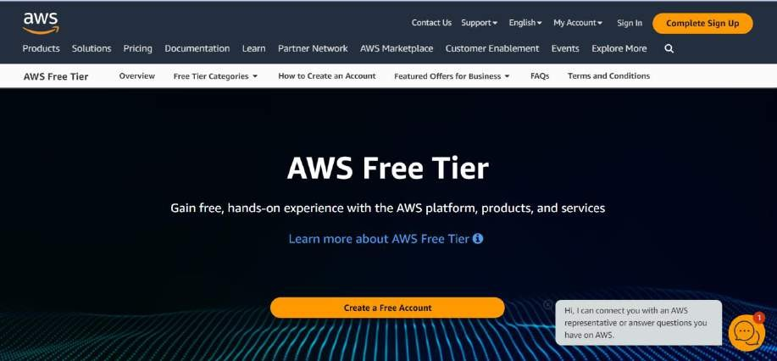

## Step 3:

Issue the details which you want to use to log in to your AWS account and click on Continue

* **Email address**: Provide the mail id which hasn’t been registered yet with Amazon AWS.
* **Password:** Type your password.
* **Confirm password**: Authenticate the password.
* **AWS Account name**: Choose a name for your account. You can change this name in your account settings after you sign up

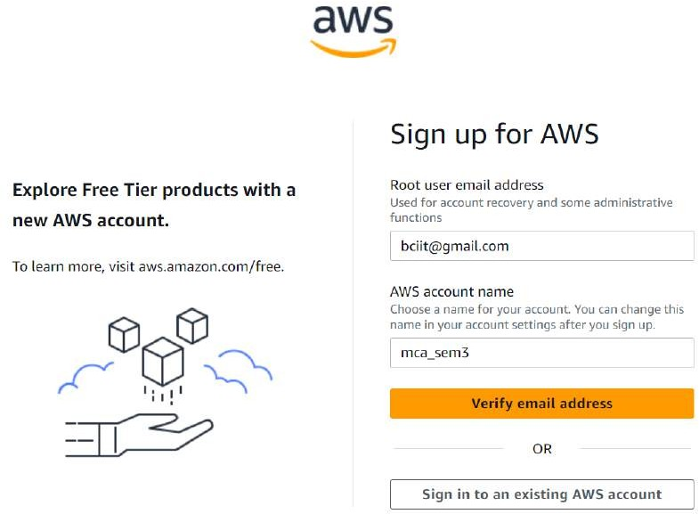

## Step 4:

**Phone verification**: Here you will be taken to an identity verification page that will already have your phone number, so you just have to select either “Text message or Voice call” Provide a valid phone number, Solve the captcha, and then click on Send SMS or Call Me Now(depending upon your selection).

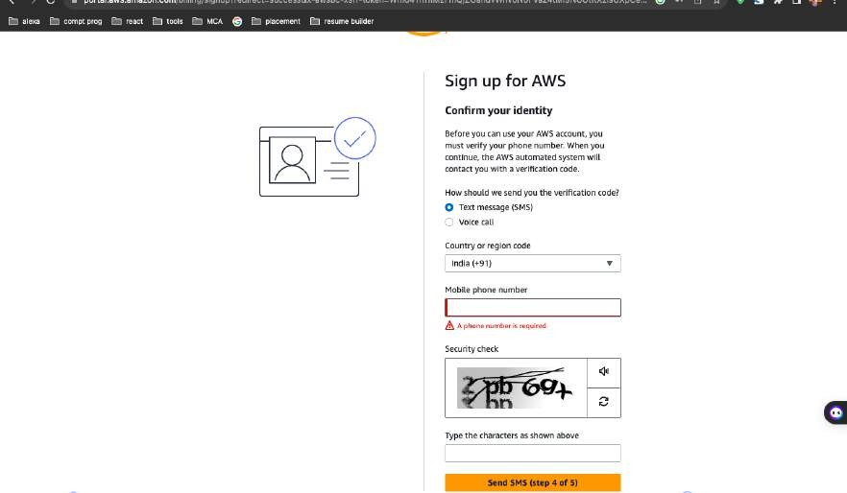

## Step 5 :

Enter your Purpose of Account Registration

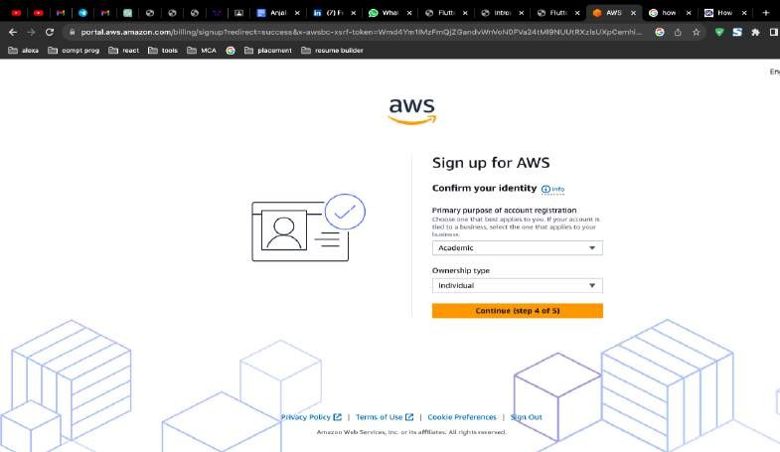

## Step 6:

After clicking on Send SMS or Call me Now, you will immediately receive a call or SMS from Amazon, for verification code, Enter your code then click on Verify Code.

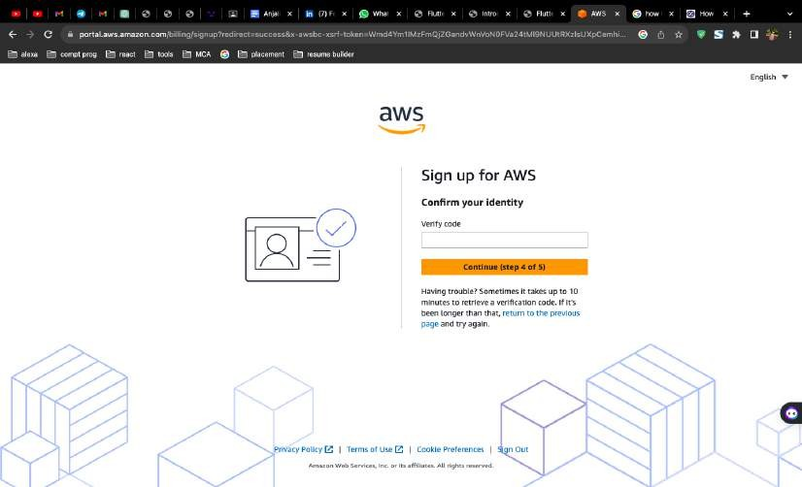

## Step 7:

**Support plan**: AWS support offers a selection of plans to meet your business needs. Select your suitable plan then click continue.

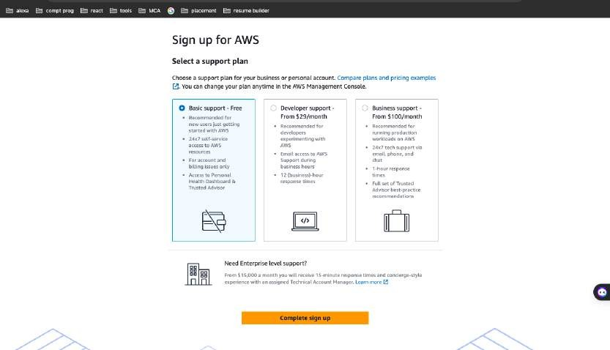

## Step 8:

### Registration Confirmation page.

Once you complete all the above steps and processes. You’ll get the confirmation page below. Now your account will be processed for activation. It may take somewhere between 30 minutes to 1 hour for you to receive an email confirmation that your Amazon Cloud Services account has been activated

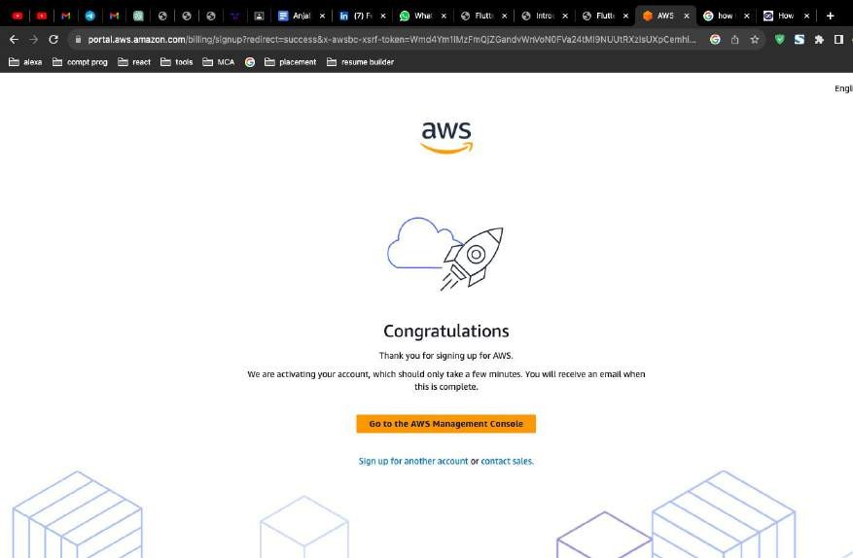

# Practical 2:

## Set up Budget to an AWS account.

**Objective :**The primary object of AWS Budgets is to help AWS customers manage and control their cloud spending effectively. AWS Budgets is a cost management tool provided by Amazon Web Services (AWS) to help organizations set and track budgets for their AWS spending. Its main objectives are:

* + Cost Monitoring: AWS Budgets provides insights into your AWS cost and usage data, allowing you to monitor your spending in real-time. This helps you keep track of your expenses and ensure they align with your budgetary goals.
  + Budget Setting: The service allows you to set specific budgets for different aspects of your AWS usage, such as overall costs, service costs, or specific cost and usage patterns. You can create custom budgets that align with your business objectives.
  + Cost Alerts: AWS Budgets enables you to set up cost and usage alerts. When your actual spending approaches or exceeds your budget thresholds, AWS Budgets will notify you via email or SNS (Simple Notification Service). This helps you take timely action to avoid unexpected overages.

### Step 1:

Sign in to the AWS Management Console and open the AWS Cost Management console at https://console.aws.amazon.com/cost-management/home.

### Step 2:

In the navigation pane, choose Budgets.

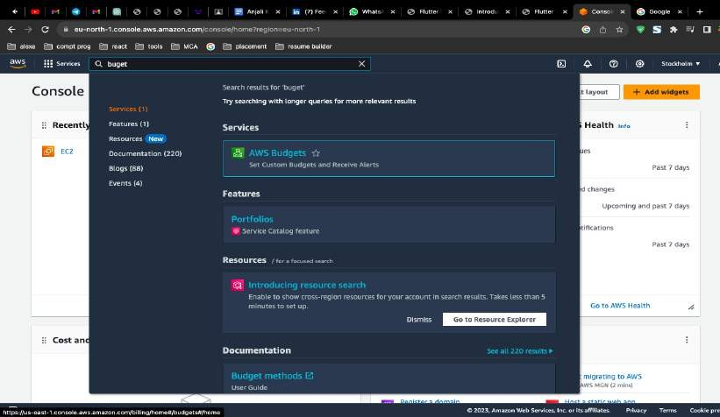

### Step 3:

At the top of the page, choose Create budget.

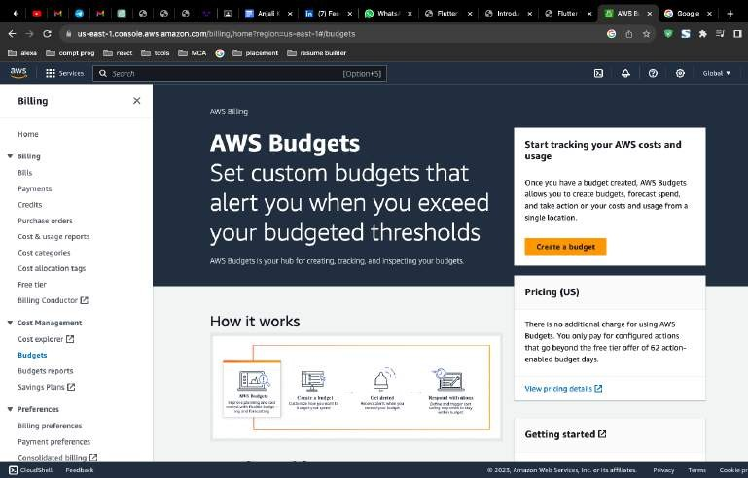

### Step 4:

Under Details, for Budget name, enter the name of your budget. Your budget name must be unique within your account. It can contain A-Z, a-z, spaces, and the following characters:

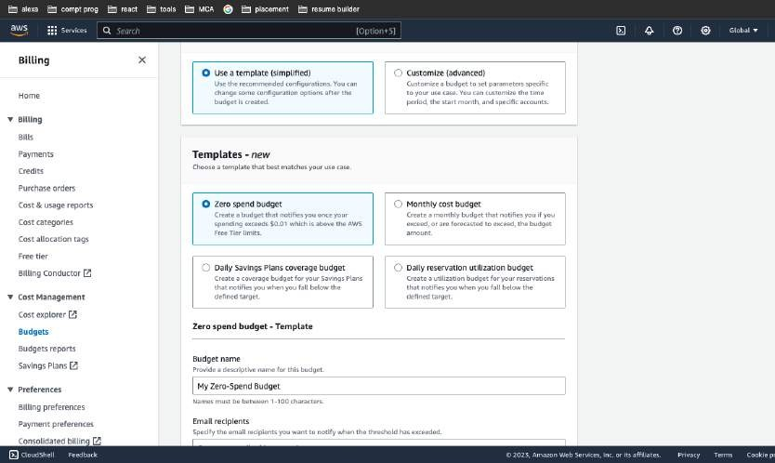

### Step 5:

Under Set alert threshold, for Threshold, enter the amount that must be reached for you to be notified. This can be either an absolute value or a percentage.

(Optional) Under Notification preferences, for Email recipients, enter the email addresses that you want the alert to notify. Separate multiple email addresses with commas. A notification can be sent to a maximum of 10 email addresses.

(Optional) Under Notification preferences, for Amazon SNS Alerts, enter the Amazon Resource Name (ARN) for your Amazon SNS topic. For instructions on how to create a topic, see Creating an Amazon SNS topic for budget notifications.

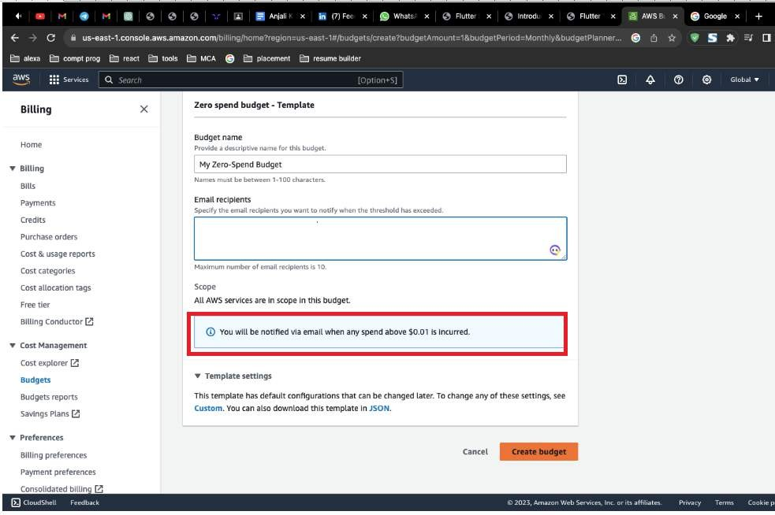

### Step 6 :

Your Aws Budget is Created

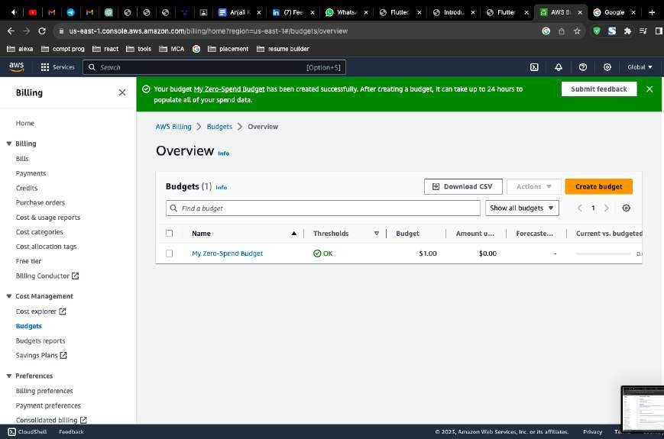

# Practical 3:

## Launch a WINDOW SERVER INSTANCE with t2.micro.instance type and create a security group by using EC2

**Objective** :Launching a Windows Server instance in AWS EC2 serves a variety of purposes, depending on your specific needs and use cases. Here are some common reasons for launching a Windows Server in AWS EC2:

* + Application Hosting: You can host Windows-based applications, including web servers, database servers, content management systems, and custom applications, on Windows Server instances in EC2.
  + Development and Testing: Windows Server instances are ideal for development and testing environments. You can create isolated development environments, test software, and simulate production environments on-demand.
  + Data Analysis and Reporting: Organizations often use Windows Servers in EC2 for data analysis, data warehousing, and generating reports using tools like SQL Server, Power BI, or custom analytics software.

### Step1:

Once logged in, navigate to the EC2 dashboard. You can do this by searching for "EC2" in the AWS Management Console's search bar or by selecting "Compute" and then "EC2" under the "Services" menu.

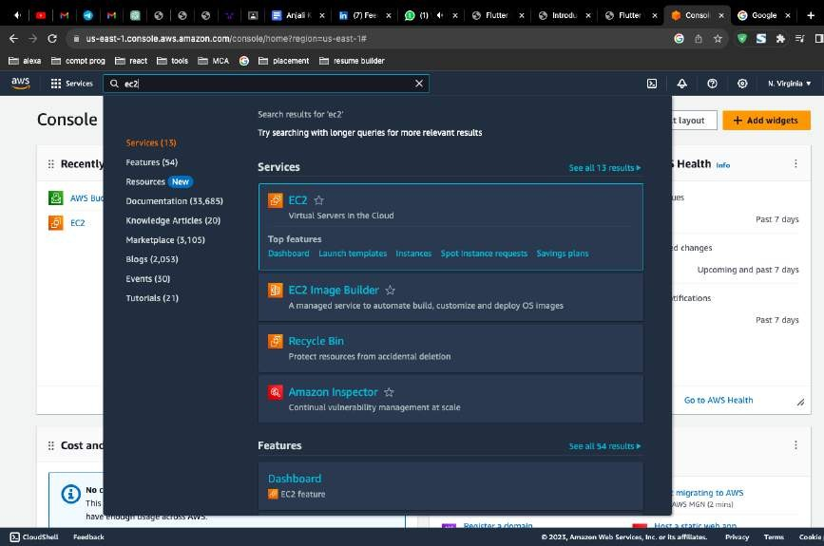

### Step 2:

Enter the name of your Aws Ec2 Instance

### Step 3:

In the "Choose an Amazon Machine Image (AMI)" step, search for a Windows Server AMI. AWS provides various Windows Server AMIs, including different Windows Server versions and editions. Select the one that suits your requirements.

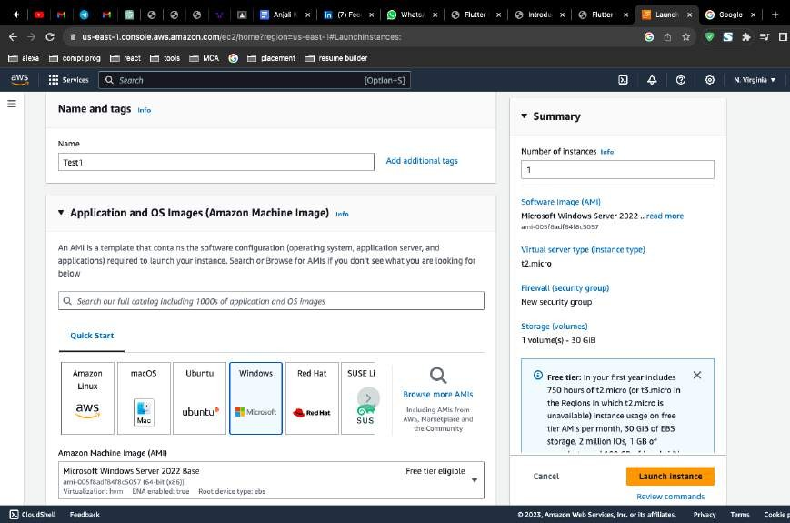

### Step 4:

In the "Add Storage" step, you can specify the size and type of the root volume for your instance. You can also add additional volumes if necessary.

### Step 5:

In the "Configure Security Group" step, you'll need to configure the security group rules. Security groups act as firewalls to control inbound and outbound traffic to your instance. Ensure that you allow Remote Desktop Protocol (RDP) for Windows instances if you plan to access them remotely.

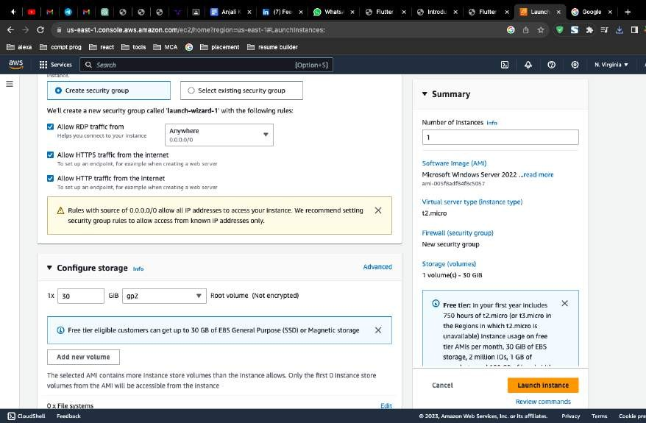

### Step 6:

If you haven't already created a key pair, you will be prompted to create one. This key pair is used to securely access your Windows Server instance. Download and save the key pair (.pem file) in a secure location.

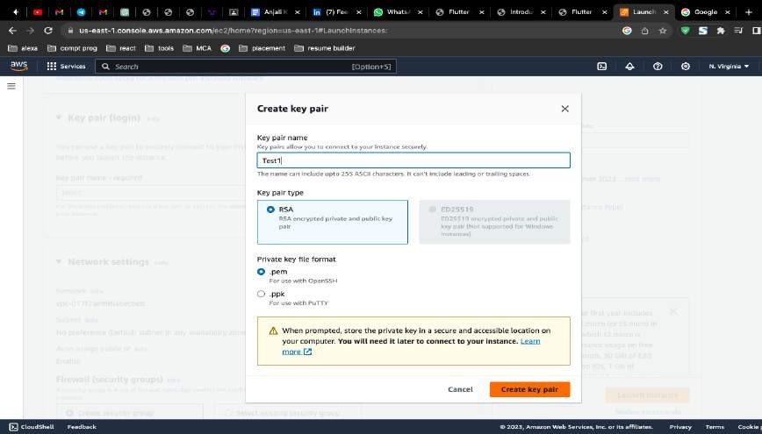

### Step 6:

After selecting or creating a key pair, click the "Launch Instances" button.

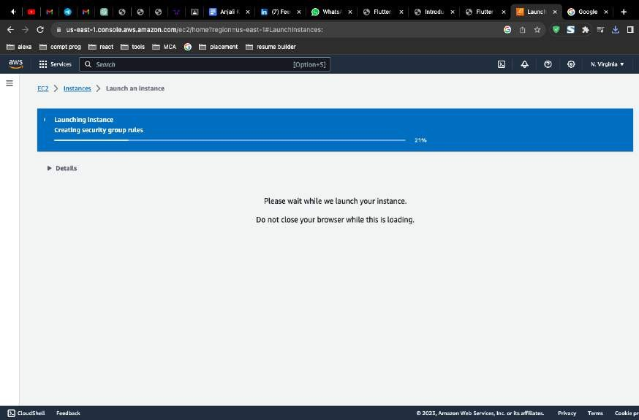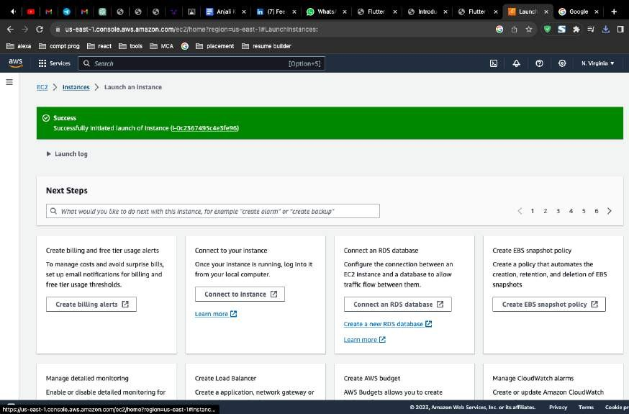

# Practical 4:

## Connect the launch instance , 2/2 status check and decrypt password by using RDP client .

### Step 1:

Select the Instance

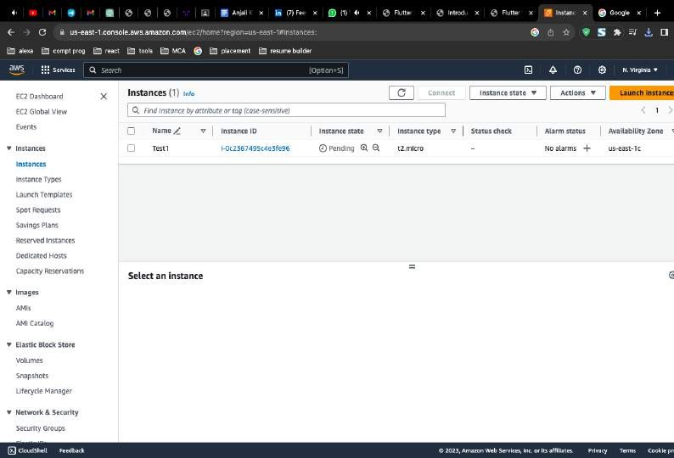

### Step 2:

You'll be taken to the "Instances" view, where you can see the status of your Windows Server instance as it starts. Once the instance is in a "running" state, you can connect to it using RDP.

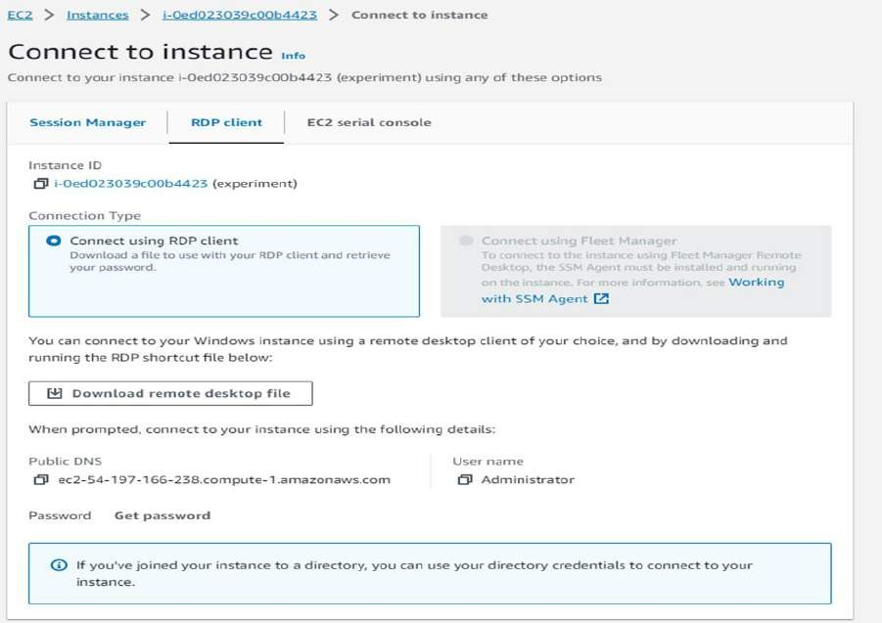

### Step 3 :

In the "Instances" view, you can see the status of your instance(s) as they transition from "pending" to "running." You can monitor the status changes there. Once the instance is in the "running" state, it means it has successfully launched, and you can then proceed to connect to it or use it for your intended purposes.

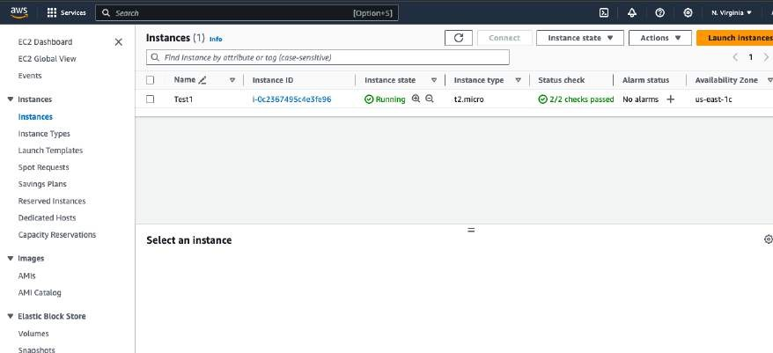

# Practical 5:

## Terminate the launched window server instance from AWS EC2.

### Step 1:

In the EC2 dashboard, click on "Instances" in the left navigation pane to view a list of your running instances.

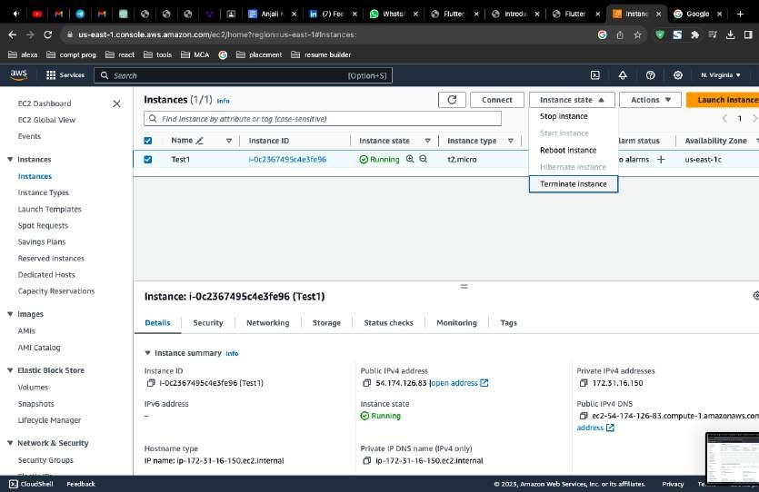

### Step 2:

With the instance selected, click the "Actions" button at the top of the dashboard, and from the dropdown menu, select "Instance State" and then choose "Terminate."

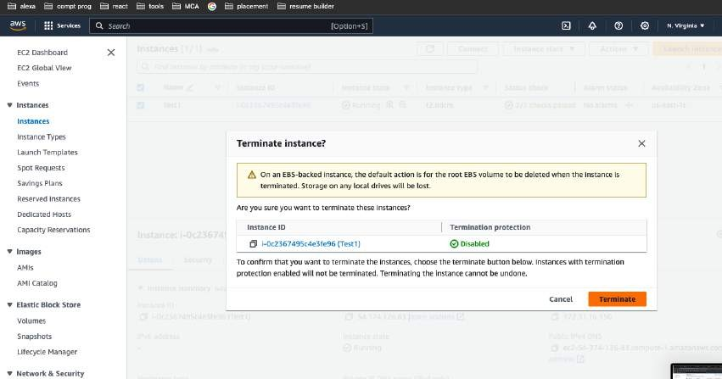

### Step 3:

AWS will now initiate the termination process. The instance will first be stopped if it was running, and then it will be permanently deleted. This process may take a few minutes.

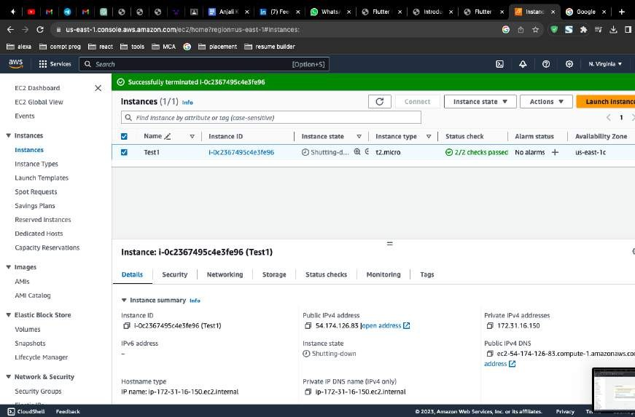

# Practical 6:

## Write the steps to launch a Linux server by using AWS EC2.

### Step 1:

Once logged in, navigate to the EC2 dashboard. You can do this by searching for "EC2" in the AWS Management Console's search bar or by selecting "Compute" and then "EC2" under the "Services" menu

.

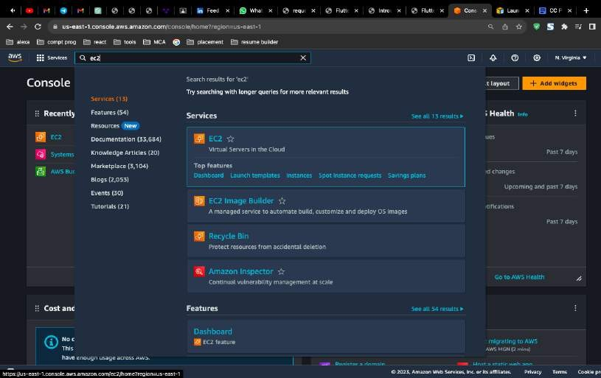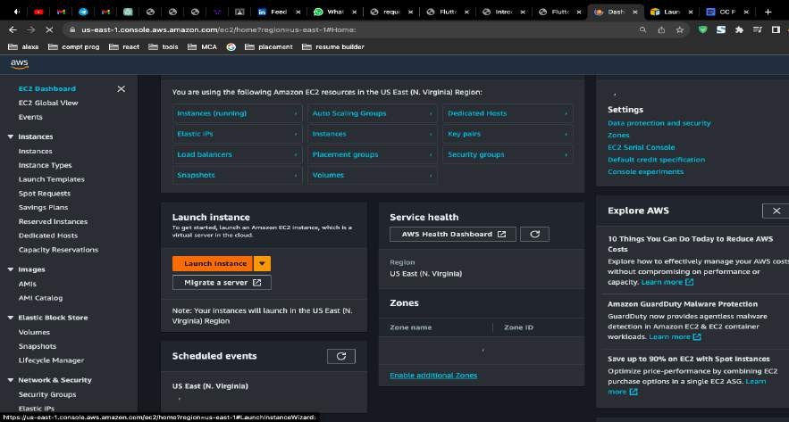

### Step 2 :

In the "Choose an Amazon Machine Image (AMI)" step, select a Linux AMI. AWS provides various Linux distributions and versions. Choose the one that suits your requirements (e.g., Amazon Linux, Ubuntu, CentOS, etc.).

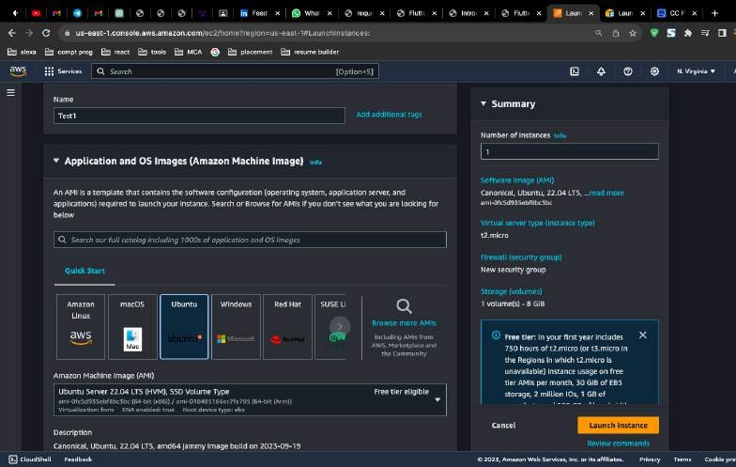

### Step 3:

If you haven't already created a key pair, you will be prompted to create one. This key pair is used to securely access your Linux server instance. Download and save the key pair (.pem file) in a secure location

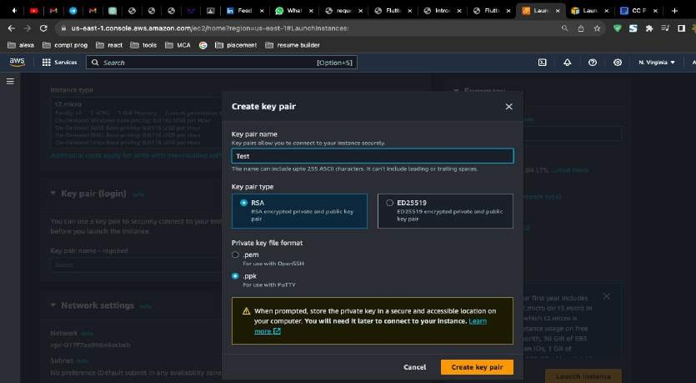

### Step 4 :

After selecting or creating a key pair, click the "Launch Instances" button.

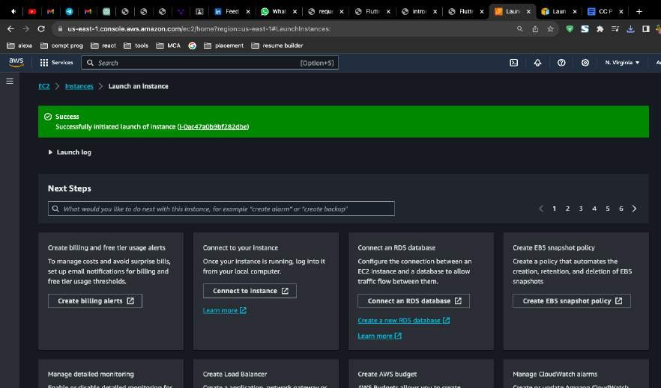

### Step 5 :

You'll be taken to the "Instances" view, where you can see the status of your Linux server instance as it starts. Once the instance is in a "running" state, it means it has successfully launched, and you can proceed to access it via SSH.

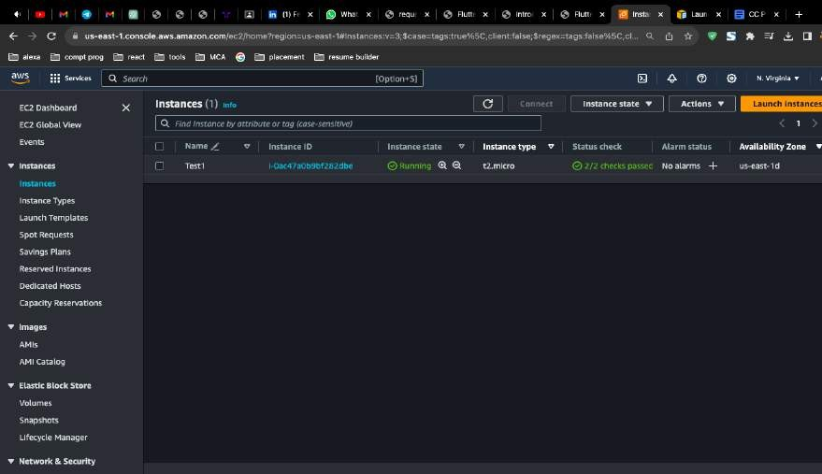

# Practical 7:

## Write the steps to connect with the window server by using AWS EC2.

### Step 1:

Create a Aws Ec2 Window Instance

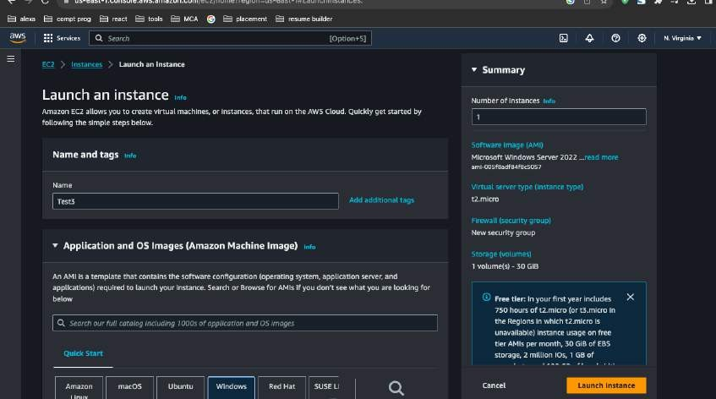

### Step 2:

In the "Configure Security Group" step, you'll need to configure the security group rules. Security groups act as firewalls to control inbound and outbound traffic to your instance. Ensure that you allow Remote Desktop Protocol (RDP) for Windows instances if you plan to access them remotely.

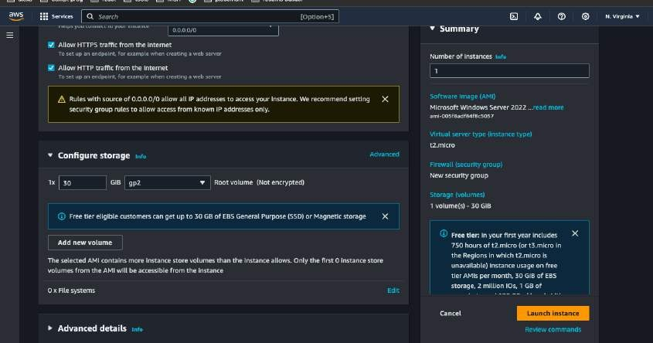

### Step 3:

Select The key pair for Instance

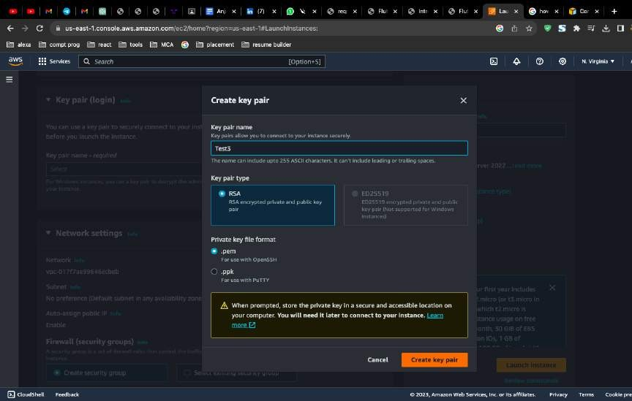

### Step 4 :

Launch Instance

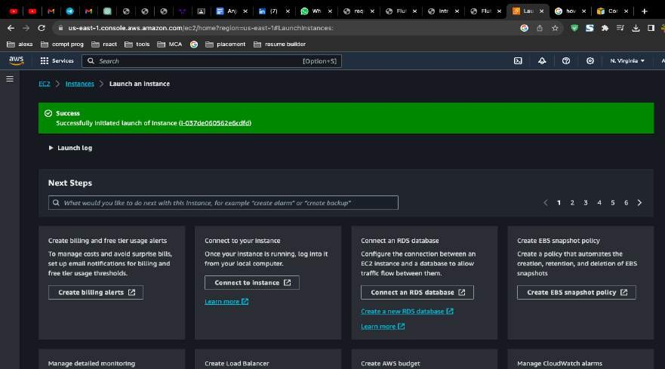

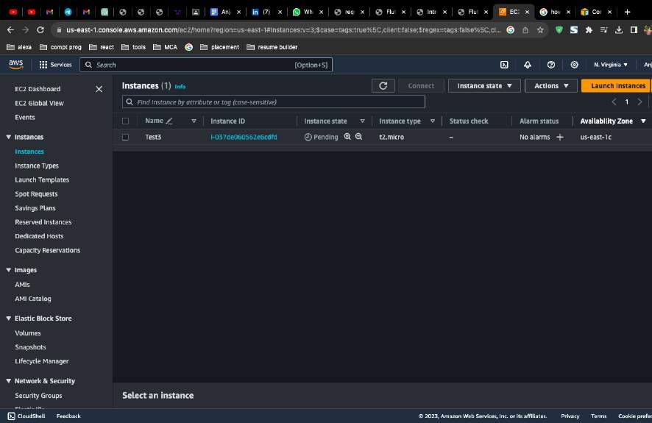

### Step 5 :

Check Instance Summary

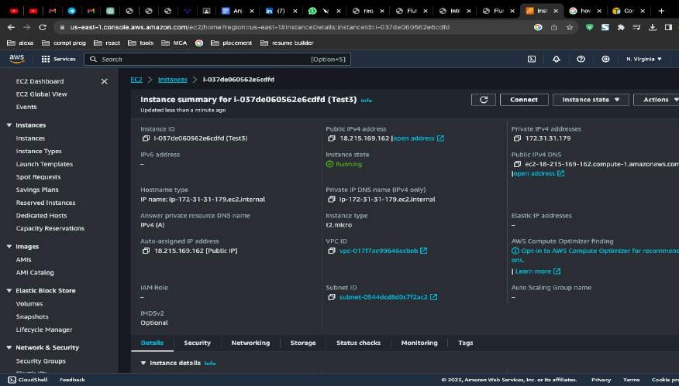

### Step 6 :

Open your RDP client and configure a new connection with the public IP address or public DNS name of your Windows Server instance. You may also need to specify the username you want to use for the remote desktop session. By default, this is usually "Administrator."

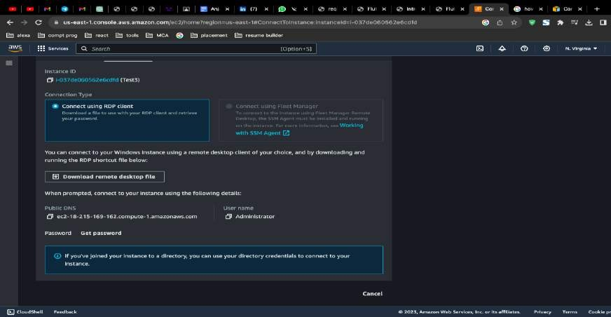

**Step 7 :** After configuring the connection, click "Connect" or "Connect" in your RDP client. You will be prompted to enter the administrator's username and password. If you haven't changed the password, you can retrieve it from the AWS Management Console.

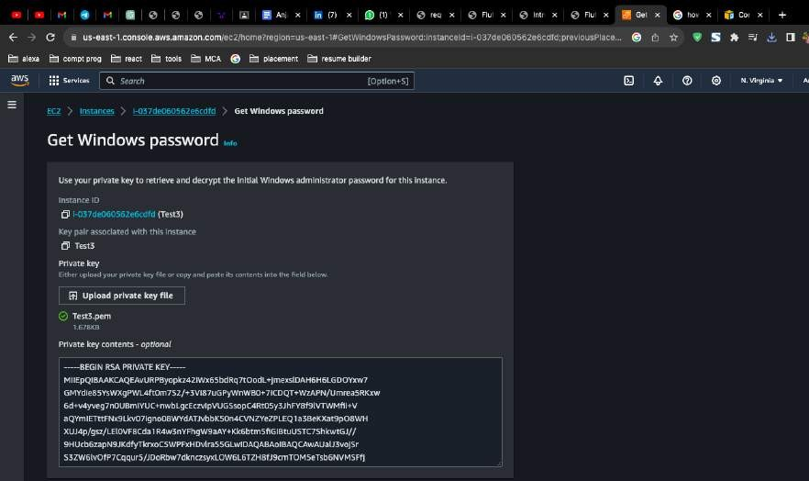

# Practical 8:

## How to launch a website on a windows server using EC2.

### Step 1:

Create a Instance

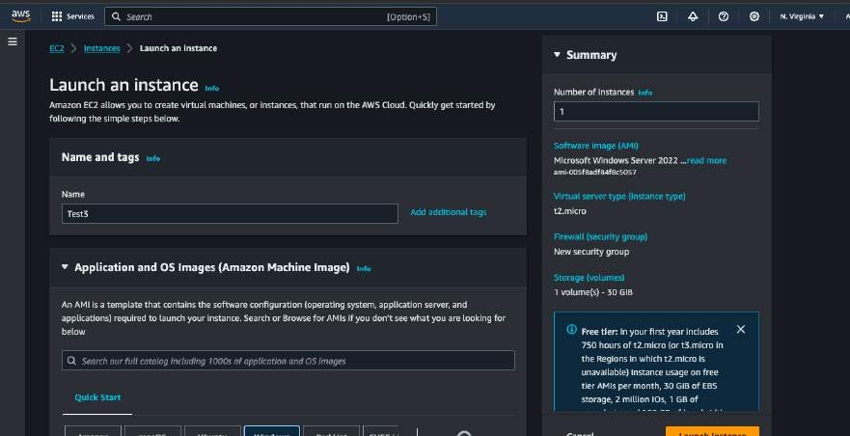

### Step 2 :

In the "Configure Security Group" step, you'll need to configure the security group rules. Security groups act as firewalls to control inbound and outbound traffic to your instance. Ensure that you allow Remote Desktop Protocol (RDP) for Windows instances if you plan to access them remotely.

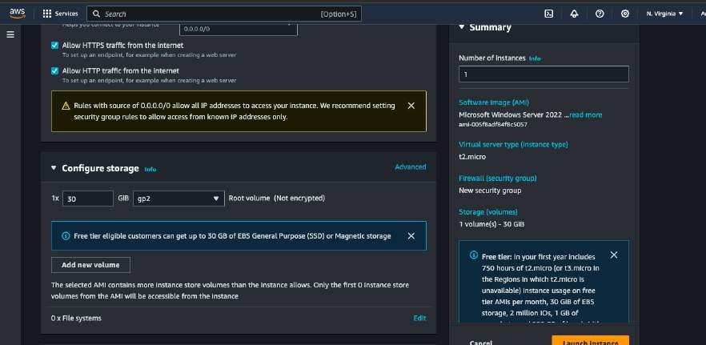

### Step 3:

Create a key pair for instance.

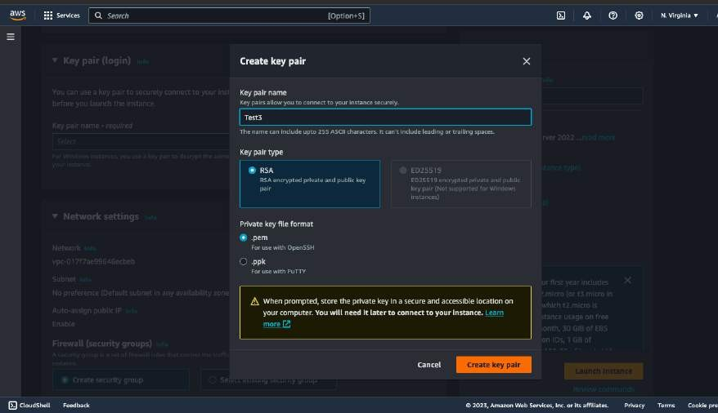

### Step 4:

Launch the instance

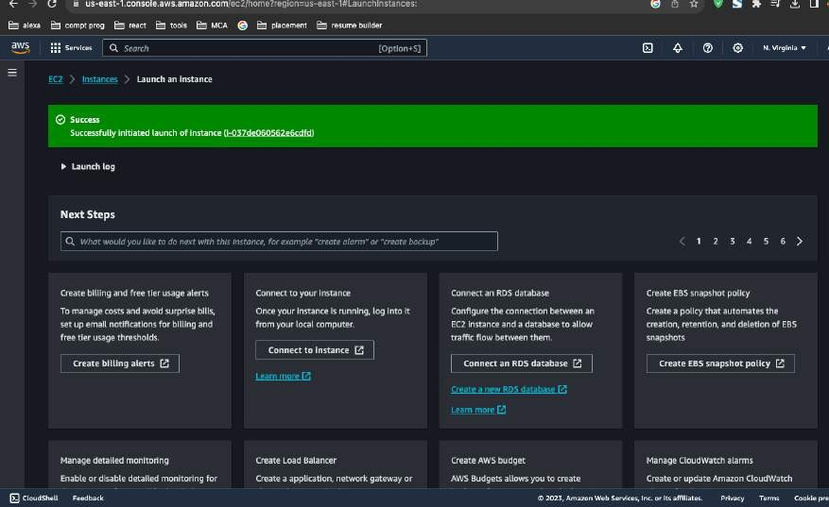

### Step 5 :

Launch the instance

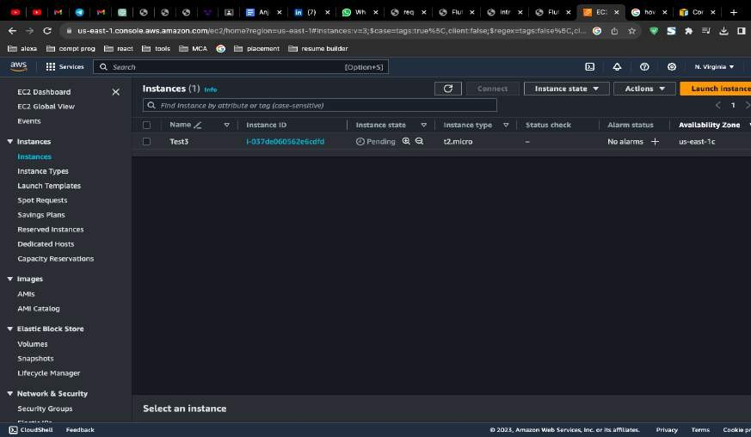

### Step 6 :

Open your RDP client and configure a new connection with the public IP address or public DNS name of your Windows Server instance. You may also need to specify the username you want to use for the remote desktop session. By default, this is usually "Administrator."

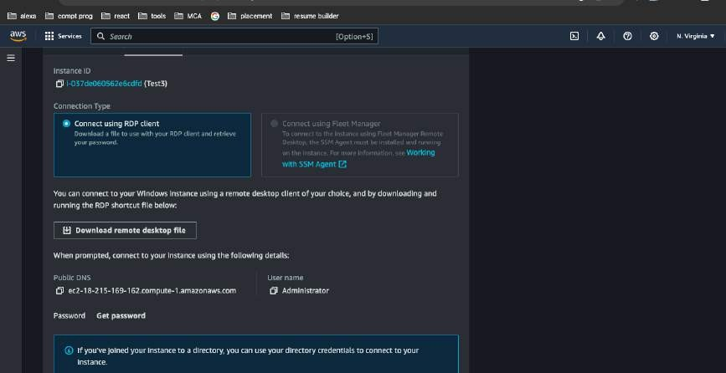

### Step 7:

After configuring the connection, click "Connect" or "Connect" in your RDP client. You will be prompted to enter the administrator's username and password. If you haven't changed the password, you can retrieve it from the AWS Management Console.

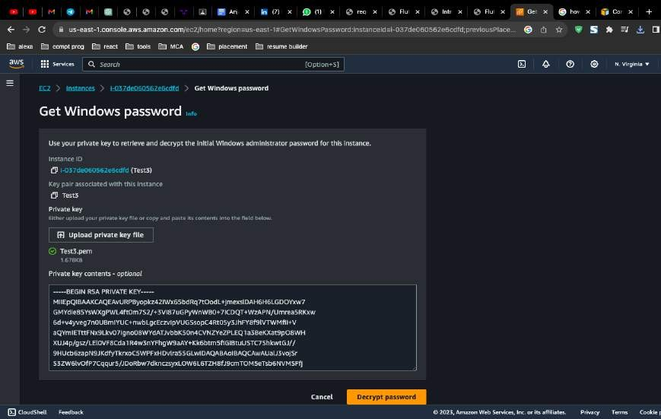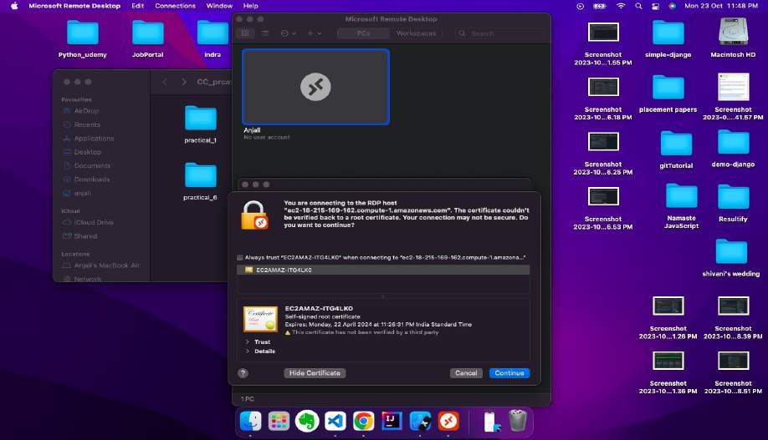

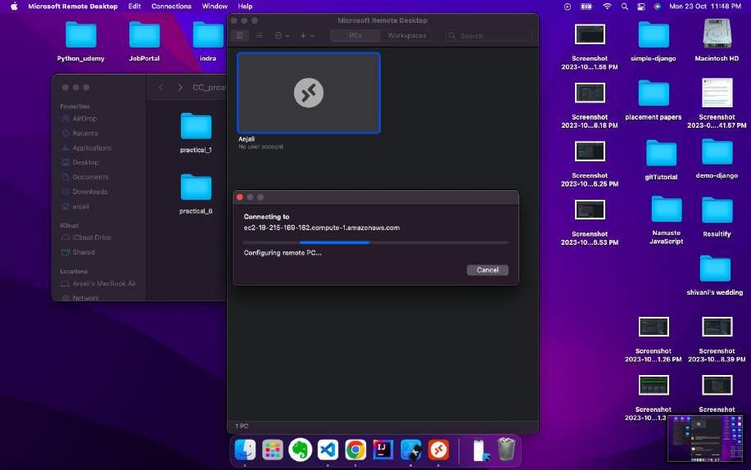

### Step 8:

To host a website, you'll need web server software. You can use Microsoft Internet Information Services (IIS) as a common choice for hosting websites on Windows Server. Follow these steps to install and configure IIS:

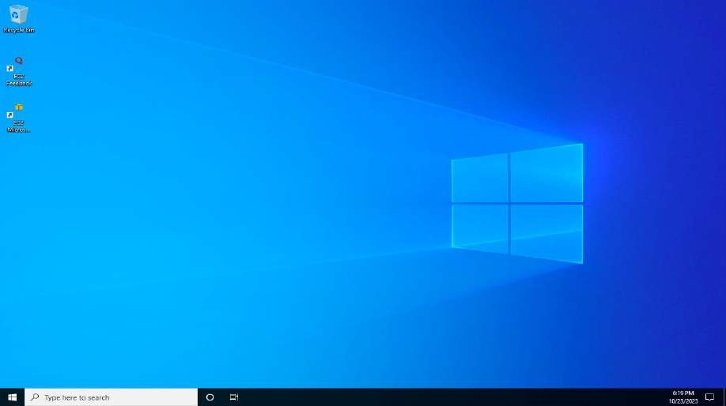

### Step 9 :

In your Windows Server instance, open "Server Manager."

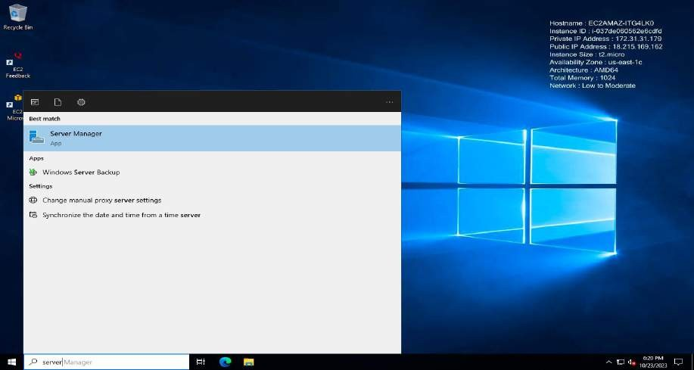

### Step 10 :

Click on "Add roles and features" and follow the wizard to install the Web Server (IIS) role.

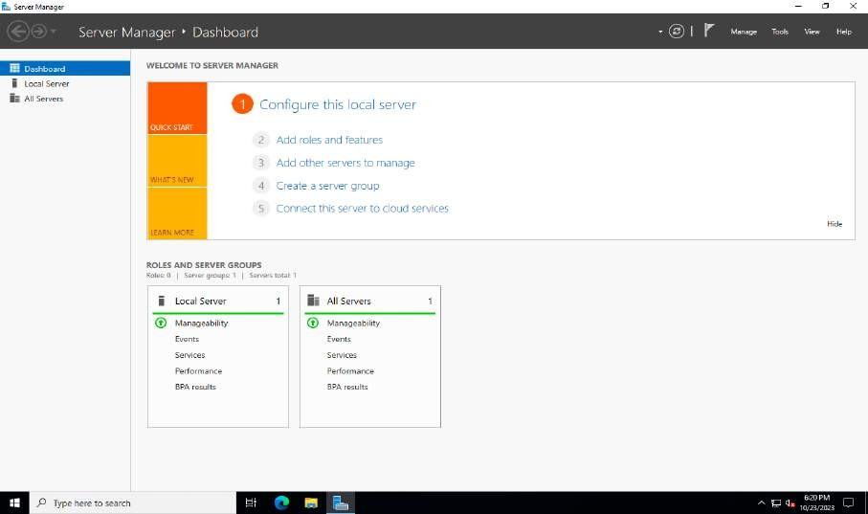

### Step 11 :

Once IIS is installed, you can configure your website by creating a new site, specifying the content directory, and setting up bindings (e.g., domain names or IP addresses).

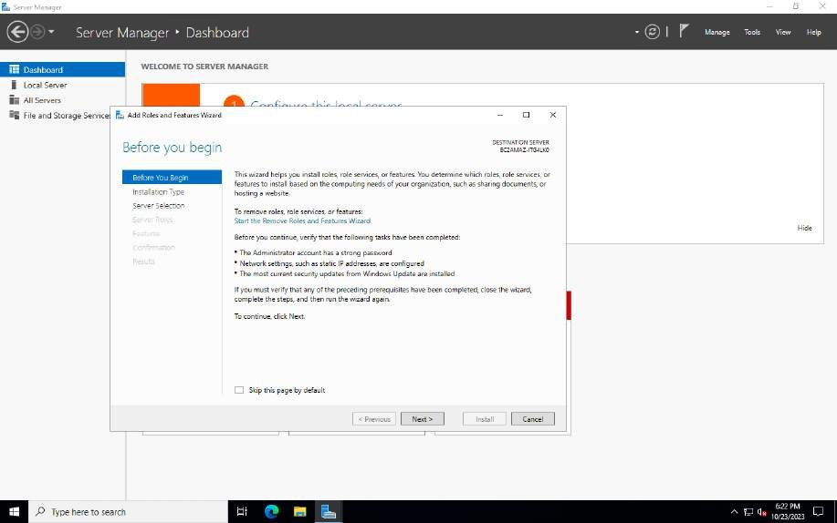

# Practical 9:

## Terminate the launched Linux server instance from AWS EC2.

### Step 1:

In the EC2 dashboard, click on "Instances" in the left navigation pane to view a list of your running instances. Locate the Linux server instance you want to terminate.

### Step 2:

Click the checkbox next to the Linux server instance you want to terminate. It will become selected.

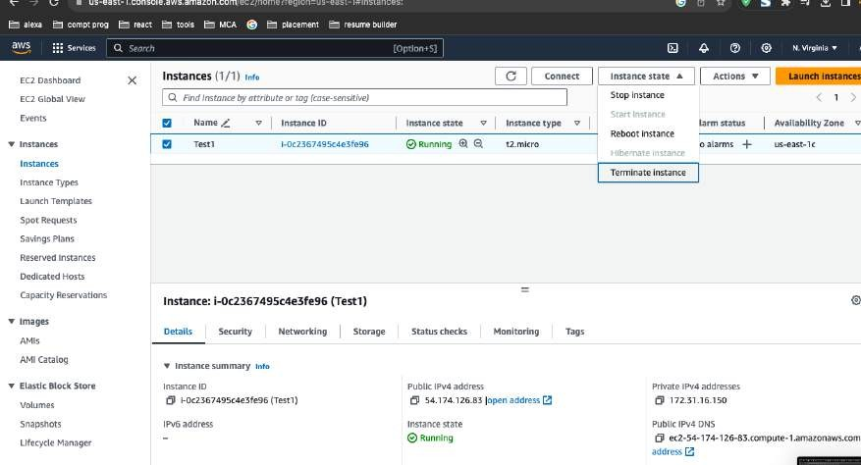

### Step 3 :

With the instance selected, click the "Actions" button at the top of the dashboard, and from the dropdown menu, select "Instance State" and then choose "Terminate."

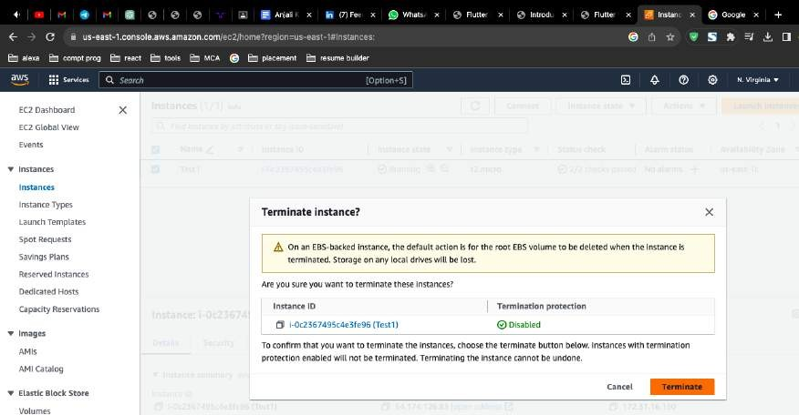

### Step 4 :

AWS will now initiate the termination process. The instance will be stopped if it was running, and then it will be permanently deleted. This process may take a few minutes.

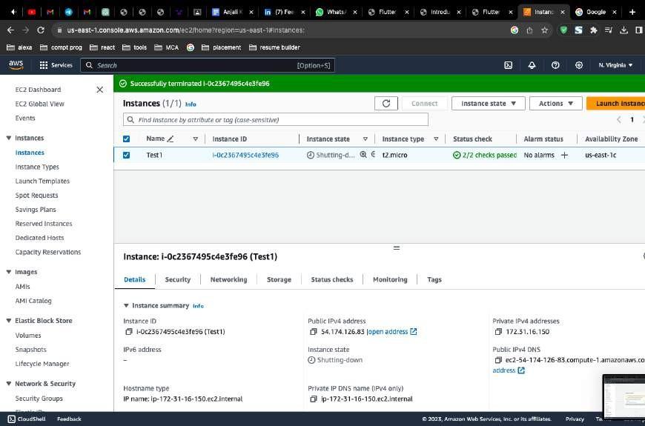

# Practical 10:

## How to create a IAM (Identify and Access management) user.

### Step 1 :

Once logged in, navigate to the IAM (Identity and Access Management) Console. You can do this by searching for "IAM" in the AWS Management Console's search bar or by selecting "Security, Identity, & Compliance" and then "IAM" under the "Services" menu.

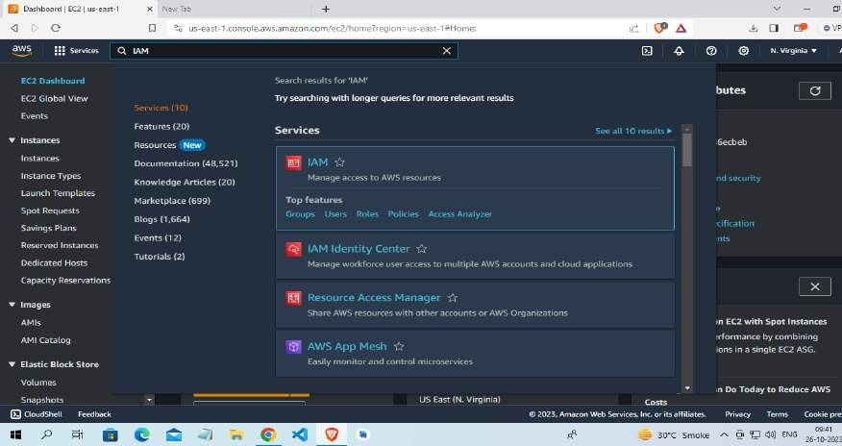

### Step 2:

In the IAM dashboard, click on "Users" in the left navigation pane to view the list of existing IAM users.

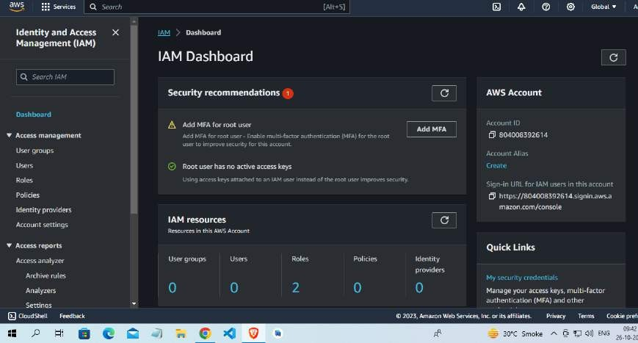

### Step 3 :

To create a new IAM user, click the "Add user" button at the top of the dashboard.

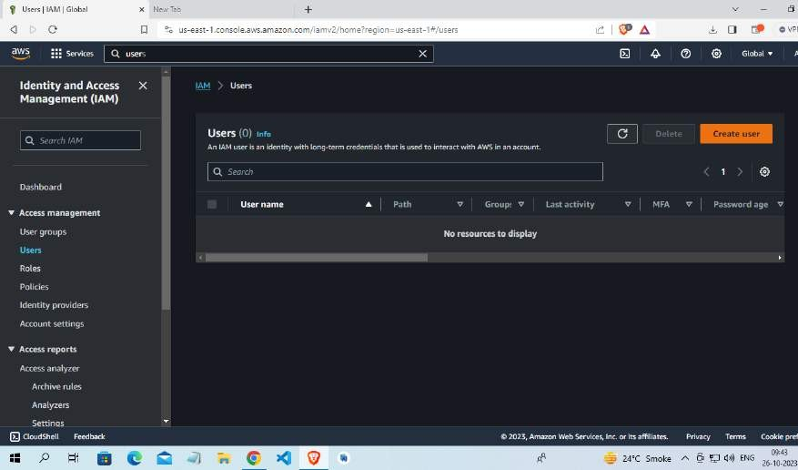

### Step 4 :

User name: Enter a unique name for the IAM user.

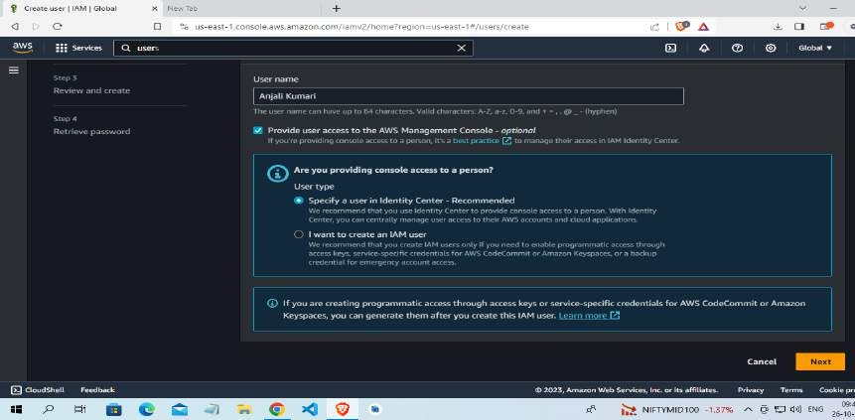

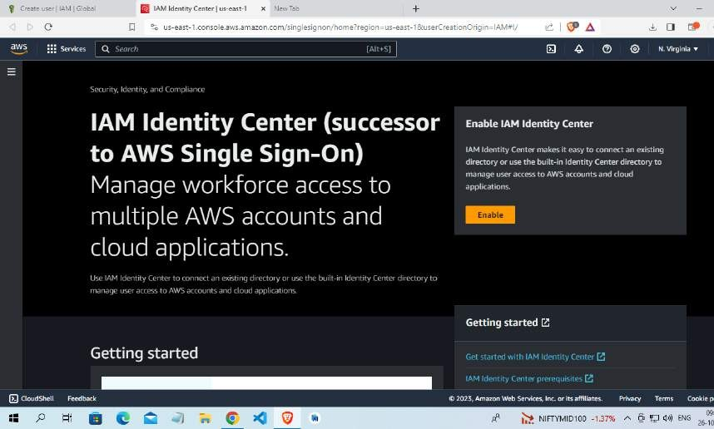

### Step 5 :

After the user is successfully created, you'll see a confirmation page. This page provides important information, such as the user's access key and secret access key (if you selected "Programmatic access"). Make sure to download and securely store the access keys because they will only be displayed once.

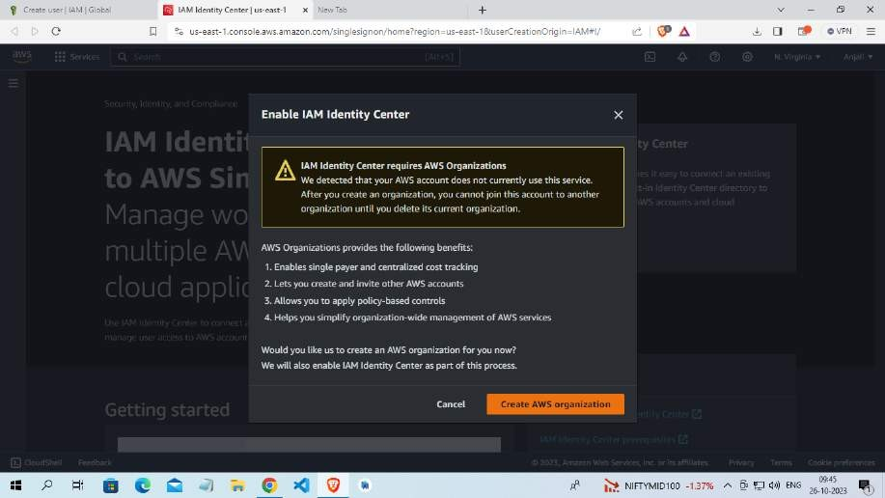

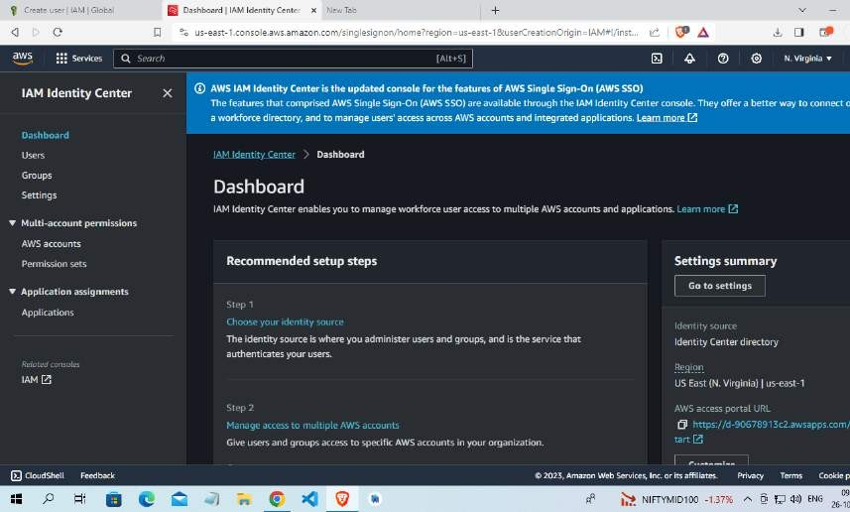

# Practical 11:

## How to connect with a launched instance of Linux (putty & putty gen software).

The objective of the practical steps I provided for connecting to a Linux server using PuTTY and PuTTYgen is to enable users to securely access and manage a remote Linux server from a Windows machine. Here's a breakdown of the objectives:

* Connect to a Remote Server: The primary objective is to establish a secure connection to a remote Linux server. This is often necessary for system administrators, developers, or users who need to perform tasks on a server located in a different location.
* Security: By using SSH (Secure Shell) and, optionally, generating an SSH key pair, the objective is to ensure a secure and encrypted connection. The SSH key pair enhances security by eliminating the need for passwords, making it difficult for unauthorized users to gain access.
* Manage the Linux Server: Once connected, the user can interact with the Linux server through the terminal window provided by PuTTY. This allows users to perform various tasks, such as software installation, file management, server configuration, and troubleshooting.

### Step 1:

Open EC2 Dashboard: Click on "Services" in the top navigation and select "EC2" under the Compute section. This will take you to the EC2 Dashboard.

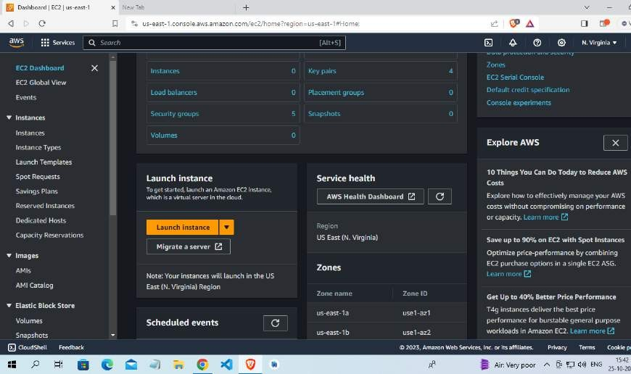

**Step 2:**

Choose an Amazon Machine Image (AMI):

Select the Linux distribution you want to use (e.g., Amazon Linux, Ubuntu, CentOS, etc.). Choose the AMI and click "Select."

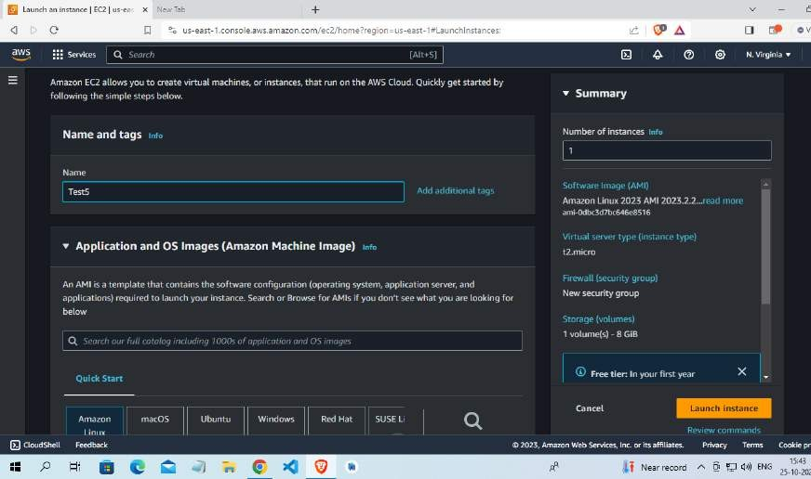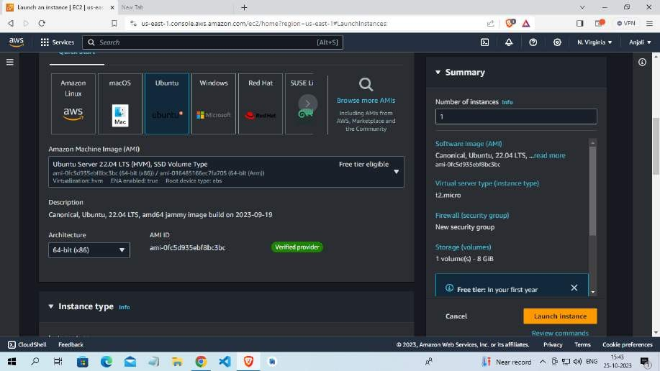

### Step 3:

Select Key Pair or Create a New Key Pair:

You'll need a key pair to securely connect to your instance. If you already have one, select it. If not, create a new key pair.

Download the key pair (.ppk) and save it in a secure location.

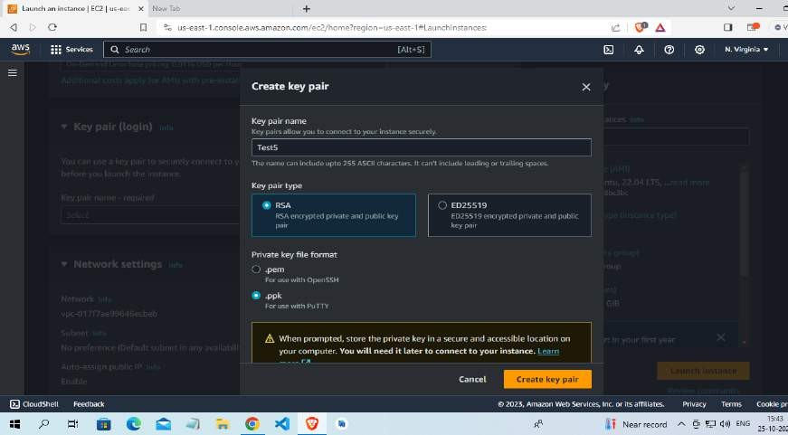

### Step 4:

Review your instance

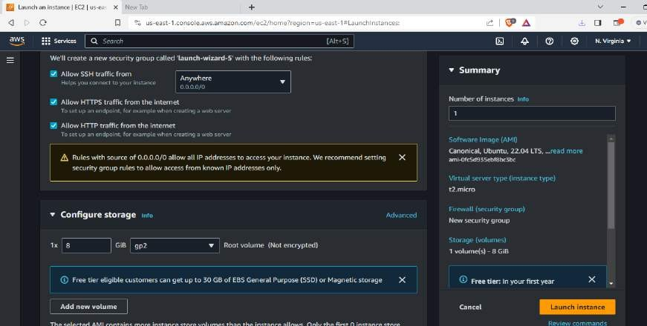

### Step 5:

Launch the Instance

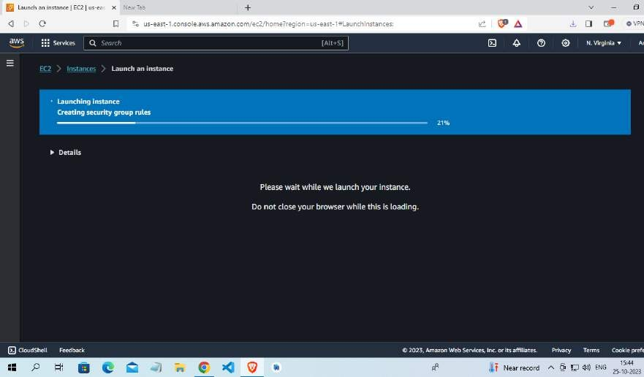

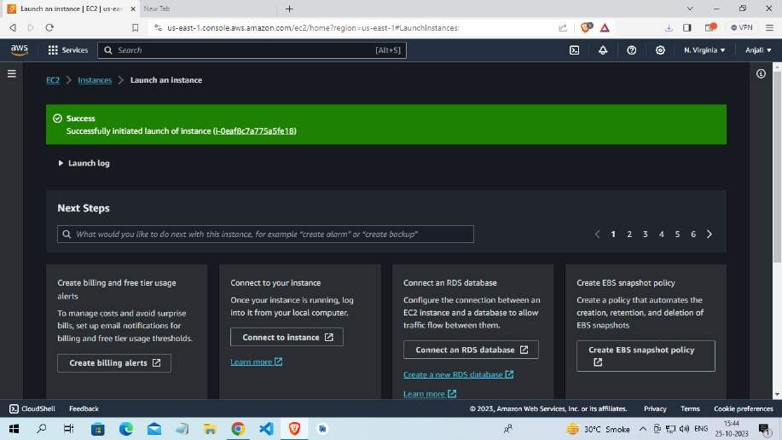

### Step 6:

Launch an Instance: Click the "Instances" link in the left sidebar and then click the "Launch Instance" button.

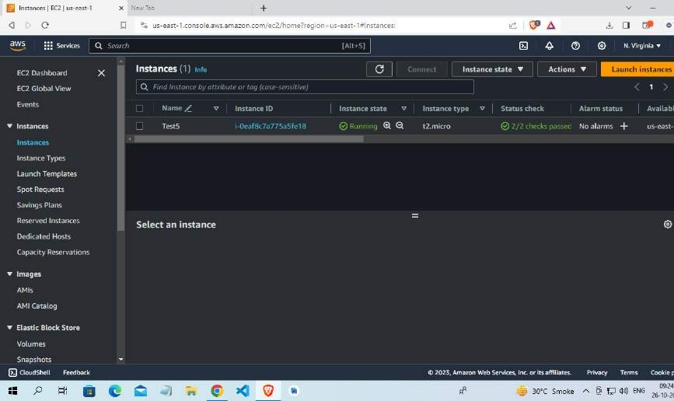

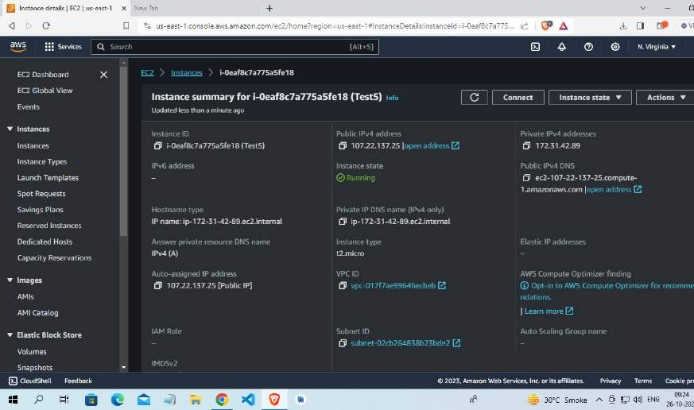

### Step 7:

Download PuTTYgen .

### Step 8:

If you are using Windows, use PuTTY and PuTTYgen to connect. For Linux and Mac users, you can use the terminal.

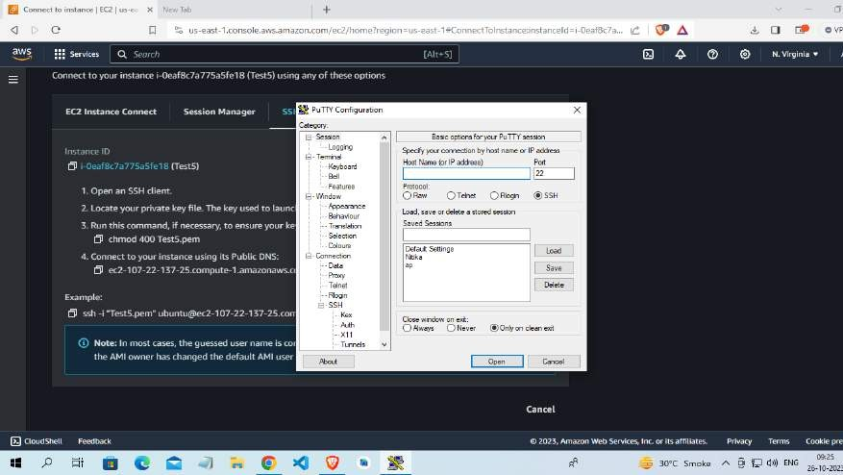

### Step 9:

Go to Connection -> ssh -> Authentication -> Credential

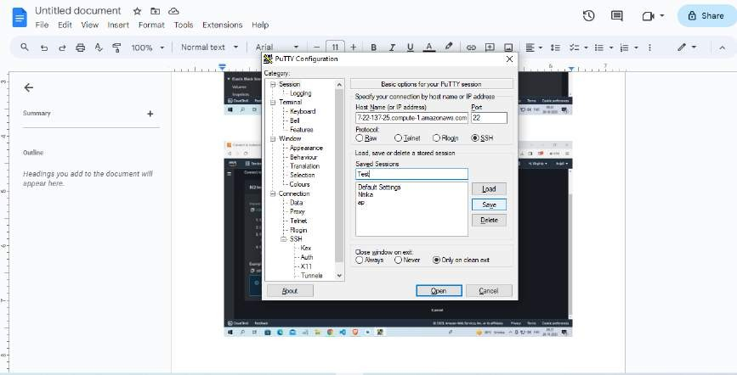

### Step 10:

If using PuTTY on Windows, use PuTTYgen to load your private key (.pem), convert it to a PPK format, and then use PuTTY to connect.

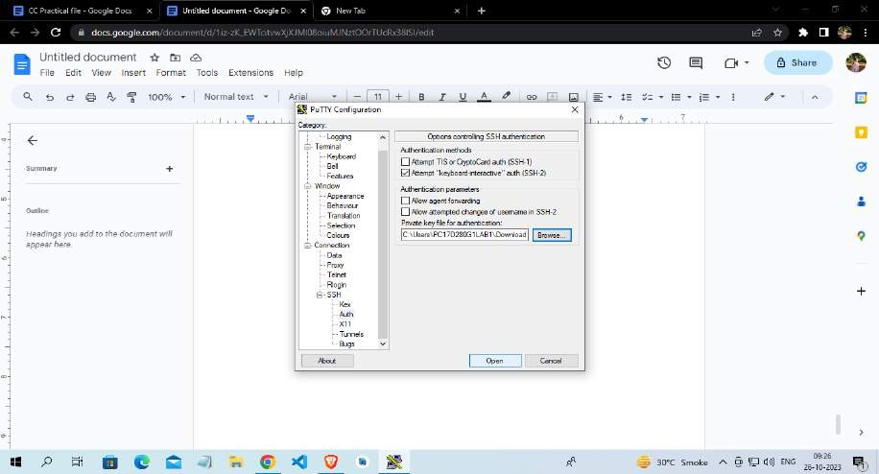

### Step 11:

Linux Instance has been Launched

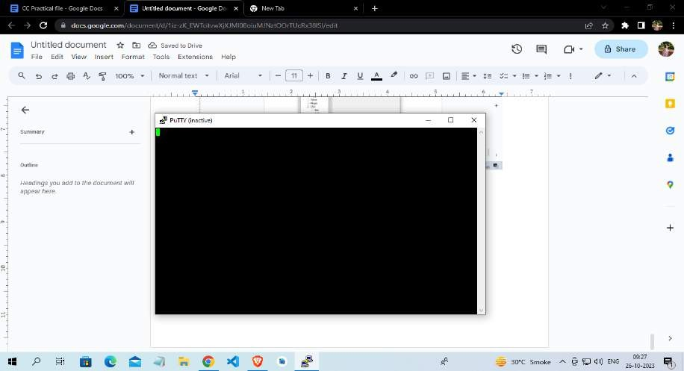

# Practical 12:

## Create IAM user and grant in limited permission to IAM user by AWS route user

### Step 1 :

Once logged in, navigate to the IAM (Identity and Access Management) Console. You can do this by searching for "IAM" in the AWS Management Console's search bar or by selecting "Security, Identity, & Compliance" and then "IAM" under the "Services" menu.



### Step 2:

In the IAM dashboard, click on "Users" in the left navigation pane to view the list of existing IAM users.



### Step 3 :

To create a new IAM user, click the "Add user" button at the top of the dashboard.



### Step 4 :

User name: Enter a unique name for the IAM user.



### Step 5 :

After the user is successfully created, you'll see a confirmation page. This page provides important information, such as the user's access key and secret access key (if you selected "Programmatic access"). Make sure to download and securely store the access keys because they will only be displayed once.



### Step 6:

Give limited permission rights by navigating to permissions

# Practical 13:

## Create a bucket by using S3 AWS service

**Objective :** The primary objective of Amazon S3 (Simple Storage Service) buckets in AWS is to provide a highly scalable, durable, and secure storage solution for a wide range of use cases. S3 buckets serve as containers for storing and managing data, and their key objectives include:

* Scalable Storage: S3 buckets can store an almost unlimited amount of data, making it suitable for organizations of all sizes. You can start with a small amount of storage and scale as needed without any disruption.
* Durability: Data stored in S3 buckets is designed to be highly durable. AWS replicates data across multiple Availability Zones, providing 99.999999999% (11 nines) durability. This means data is protected against hardware failures, and even if an entire Availability Zone goes down, your data is still safe.
* Data Availability: S3 provides high data availability. Your data is accessible over the internet, and you can access it from anywhere with an internet connection. This makes it a suitable solution for content delivery and web hosting.
* Data Security: S3 buckets offer various security features, including access control through bucket policies, IAM roles, and Access Control Lists (ACLs). You can also enable server-side encryption to protect data at rest.

### Step 1:

Once logged in, navigate to the S3 dashboard. You can do this by searching for "S3" in the AWS Management Console's search bar or by selecting "Storage" and then "S3" under the "Services" menu.

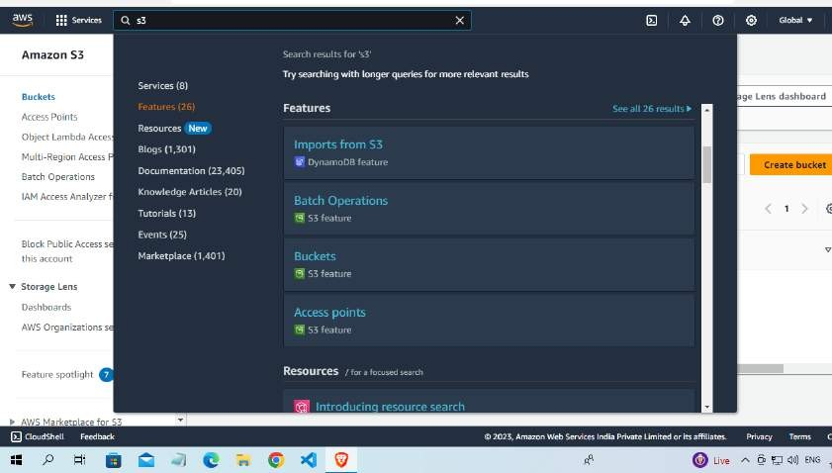

### Step 2:

Click the "Create bucket" button.

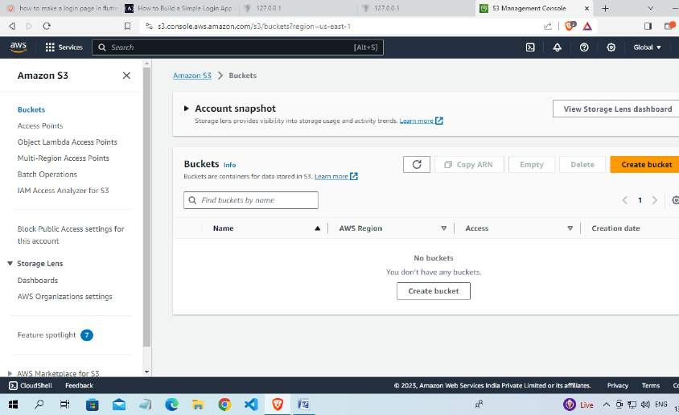

### Step 3:

In the "Bucket name" field, enter a unique and globally-unique name for your bucket. Bucket names must be unique across all of AWS.

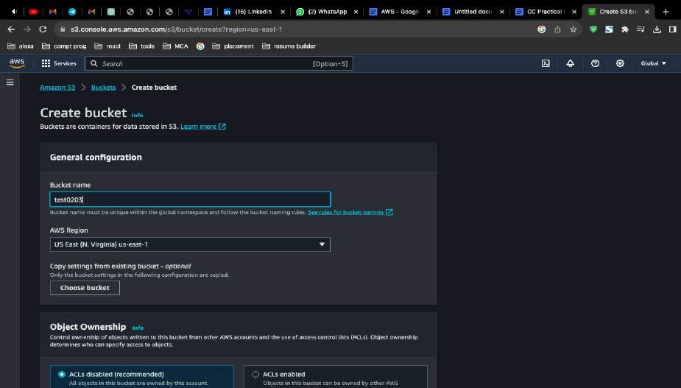

### Step 4:

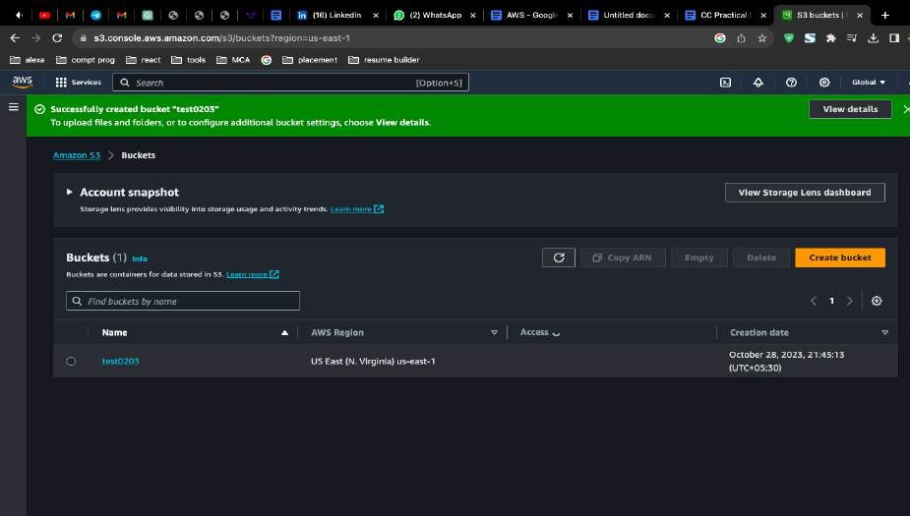Review your configuration and click the "Create bucket" button to create your S3 bucket.

# Practical 14:

## Upload an object on bucket created by using S3 AWS service

**Objective :** The objective of the practical task "Upload an object on bucket created by using S3 AWS

service”

is to demonstrate how to upload files to an Amazon S3 bucket This can be useful for various purposes, such as hosting static websites, sharing files, or distributing public content.

### Step 1:

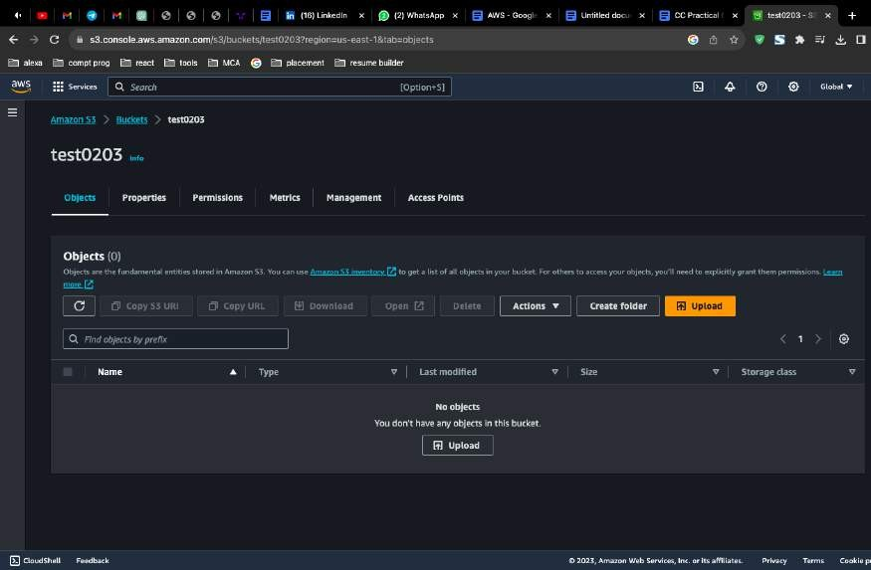Select the object (file) you want to make publicly accessible by checking the checkbox next to its name.

**Step 2:** Click the "Actions" button, and from the dropdown menu, select "Make public."

Note: If you want all objects in the bucket to be public, you can modify the bucket's access control settings to allow public access.

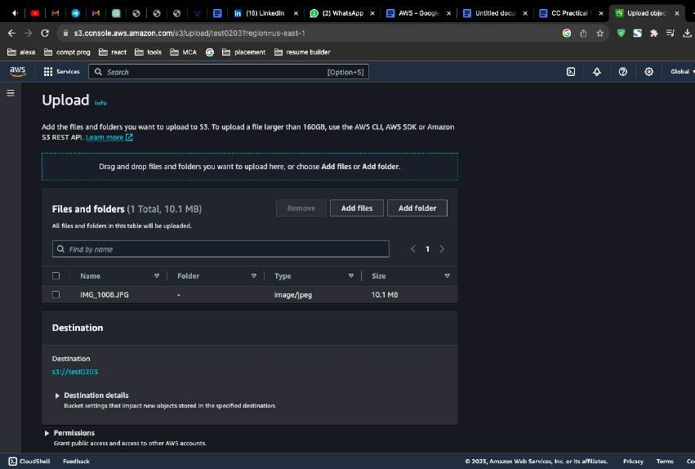

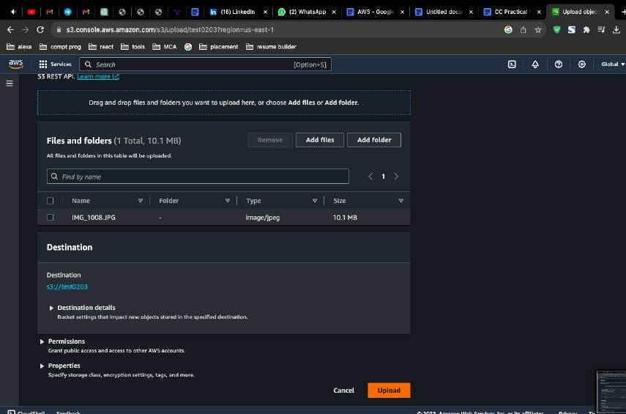

### Step 3:

File Uploaded in Buket

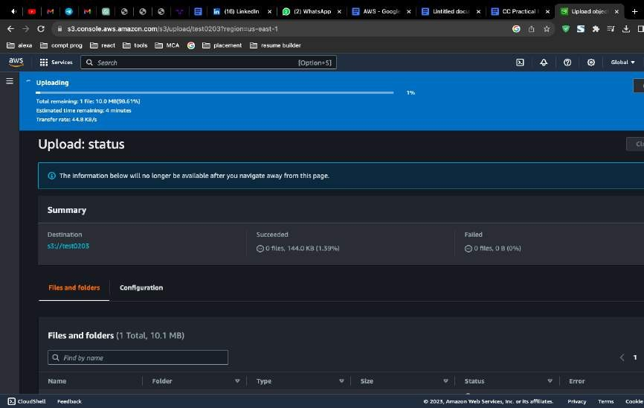

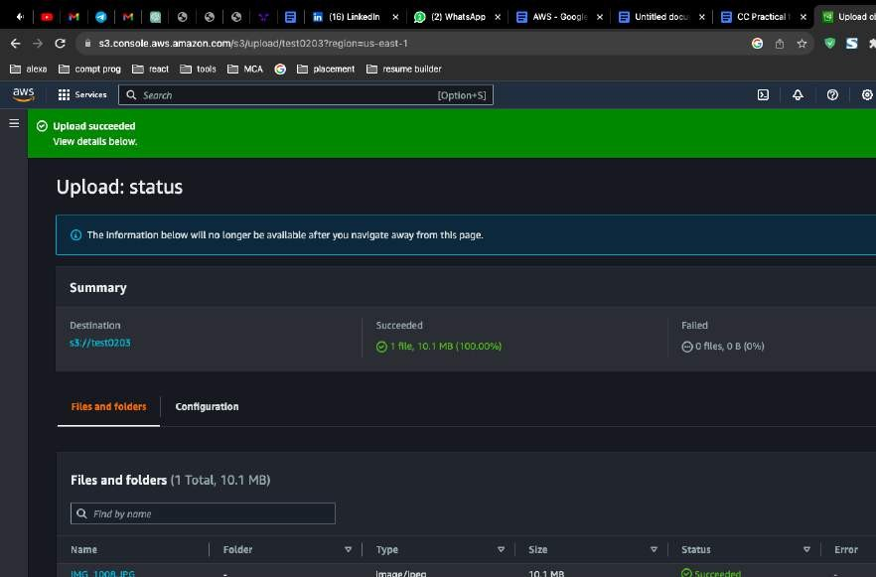

# Practical 15:

## Upload objects and enable it by using URL to get public access in the created bucket.

**Objective :** The objective of the practical task "Upload objects and enable public access via URL in a created Amazon S3 bucket" is to demonstrate how to upload files to an Amazon S3 bucket and configure the bucket settings to make those objects publicly accessible via a URL. This can be useful for various purposes, such as hosting static websites, sharing files, or distributing public content.

### Step 1:

Select the object (file) you want to make publicly accessible by checking the checkbox next to its name.



### Step 2:

Click the "Actions" button, and from the dropdown menu, select "Make public."

**Note:** If you want all objects in the bucket to be public, you can modify the bucket's access control settings to allow public access.



### Step 3:

File Uploaded in Buket





### Step 5 :

Go to permissions and click on bucket owner enforced

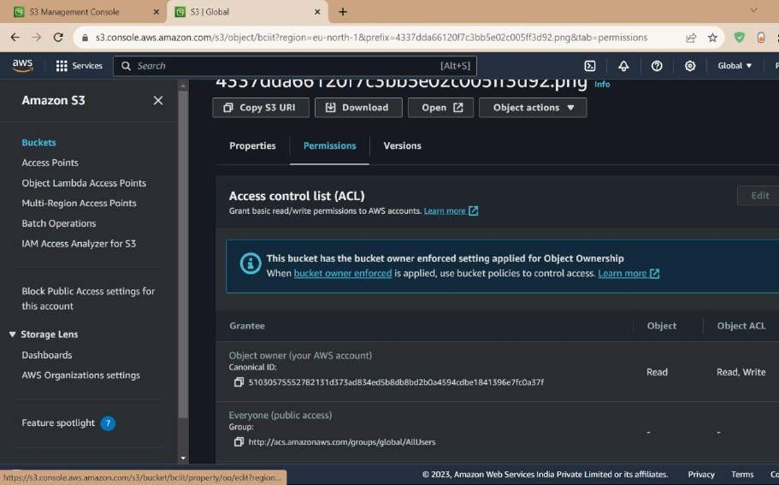

### Step 6:

click on ACL2 enabled

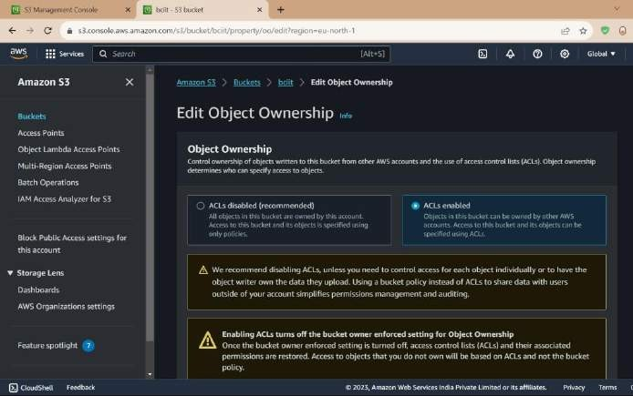

### Step 7 :

give access to read and write

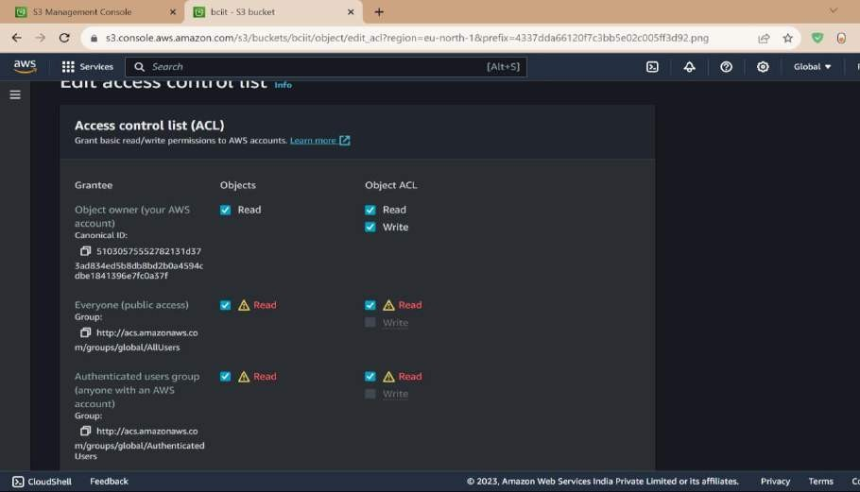

### Step 8:

Navigate to S3 terminal and paste the object URL

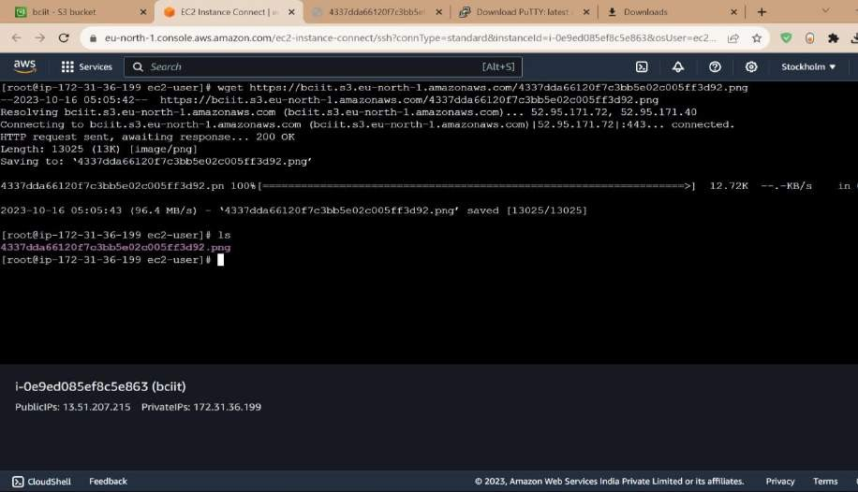

# Practical 16:

## Delete the created object and its bucket.

**Objective** : The objective of deleting objects in an Amazon S3 (Simple Storage Service) bucket in AWS can vary depending on the specific use case and needs of the user. Here are some common objectives for deleting objects from an S3 bucket:

* Data Cleanup: Removing outdated or unnecessary objects to free up storage space and reduce storage costs. Over time, old versions of files or expired data can accumulate, and deleting them helps maintain an efficient storage environment.
* Security: Deleting sensitive or confidential data that is no longer needed to reduce the risk of unauthorized access or data breaches. This is especially important for compliance with data privacy regulations.
* Version Control: Managing versioned objects by removing older versions of files that are no longer relevant. This ensures that only the most up-to-date versions are retained.
* Archiving: Deleting objects that have been archived to more cost-effective storage classes, such as Amazon Glacier, when they are no longer needed in the original S3 bucket.
* Temporary Files: Removing temporary files or objects that were only needed for a specific task or process. This helps in keeping the bucket organized and reducing clutter.

### Step 1:

In the S3 dashboard, click on the name of the bucket from which you want to delete objects.

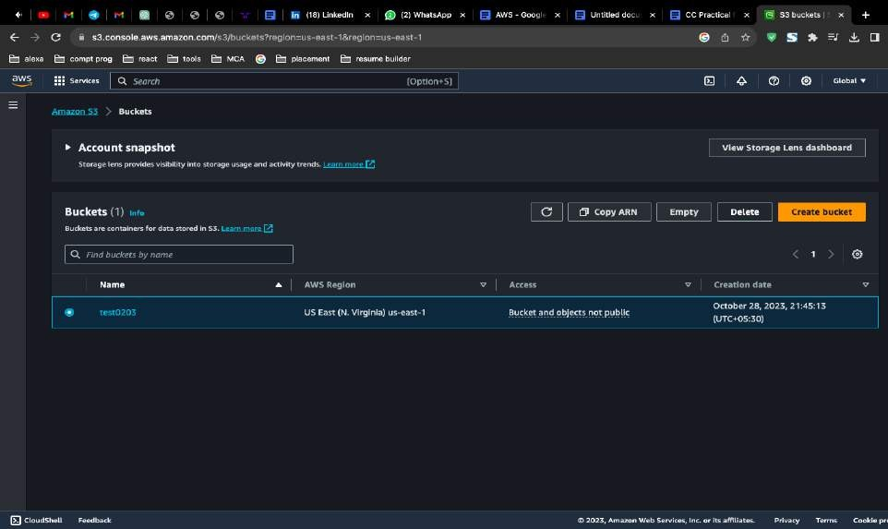

### Step 2:

In the bucket, navigate to the objects you want to delete. You can do this by clicking on the folders and subfolders, if applicable, to locate the objects.

* Select the objects you wish to delete by checking the checkboxes next to their names.
* Once the objects are selected, you can choose one of the following methods to delete them:
* Click the "Actions" button, then select "Delete" to delete the selected objects.
* Alternatively, you can simply press the "Delete" key on your keyboard after selecting the objects.
* Confirm the deletion by clicking "Delete" in the confirmation dialog.

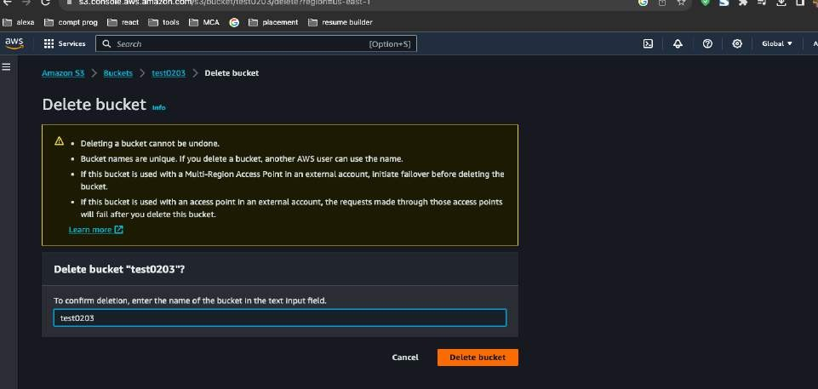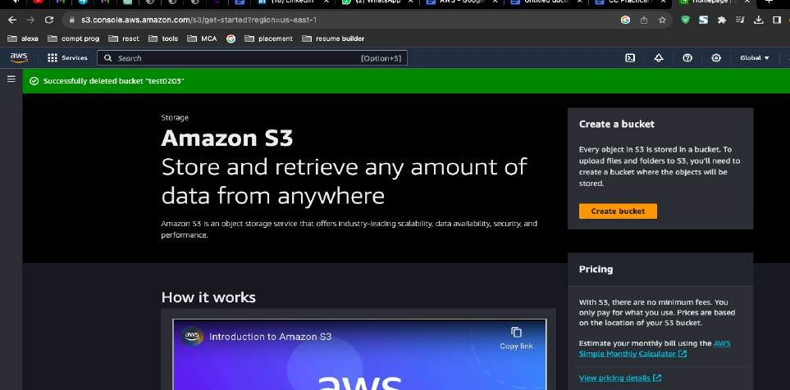

# Practical 17:

# Transfer the object file from S3 service to EC2 launched Linux server install GCC and wget commands in this regard on terminal

**Objective** : Transfer an object file from S3 to a Linux server running on EC2. Install GCC and wget on the server using terminal commands in AWS.

* Data Cleanup: Removing outdated or unnecessary objects to free up storage space and reduce storage costs. Over time, old versions of files or expired data can accumulate, and deleting them helps maintain an efficient storage environment.
* Security: Deleting sensitive or confidential data that is no longer needed to reduce the risk of unauthorized access or data breaches. This is especially important for compliance with data privacy regulations.

# Step 1: Connect to your EC2 instance via SSH.

# Open a terminal application.

# Type the ssh command followed by the username and IP address of your EC2 instance. For example:

# ssh username@ec2-public-ip-address

# Enter your password when prompted.

# Step 2: Install wget:

# Type the following command to update the package list:

# Ubuntu/Debian:

# sudo apt install wget

# Step 3: Get the S3 object URL:

# In the AWS Management Console, navigate to the S3 bucket containing the object file.

# Right-click the object and select "Get Object URL".

# Copy the URL to your clipboard.

# Step 4: Transfer the object file to EC2 using wget:

# In the SSH terminal window, type the following command, replacing URL_OF_S3_OBJECT with the URL you copied:

# wget URL_OF_S3_OBJECT

# 2.Press Enter. The file will be downloaded to your current directory on the EC2 instance.

# Step 5: Verify the file transfer:

# 1.Type the following command to list the files in your current directory:

# ls -l

# 2.Make sure the object file is listed.

# Step 6: Install GCC:

# 1.Update the package list again:

# 2.Install GCC using the appropriate command for your Linux distribution:

# Ubuntu/Debian:

# sudo apt install gcc

# Step 7: Verify GCC installation:

# 1.Type the following command to check the installed GCC version:

# gcc –version

# 2.The command should display the installed GCC version.

# Screenshots:

# 1. Object URL in S3 Console:

# wget command in terminal:

# 3. File listing showing downloaded object:

# GCC installation command:

# Image of GCC installation command screenshot

# 5. GCC version verification:

# Practical 18:

## Create VPC and implement EC2 services on it.

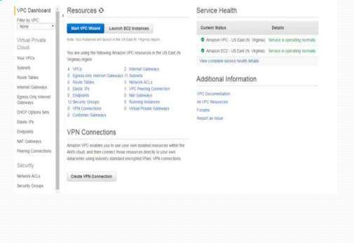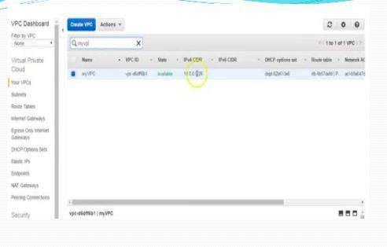

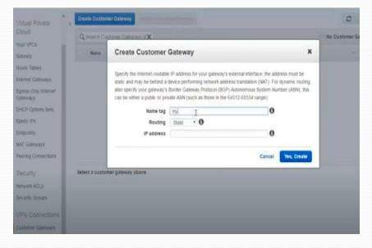

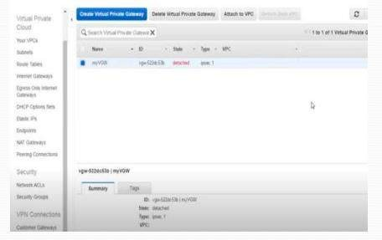

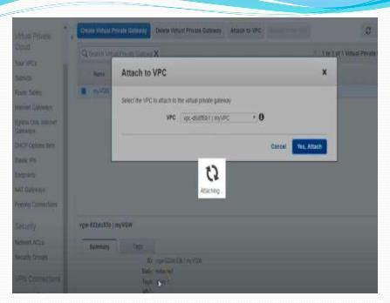

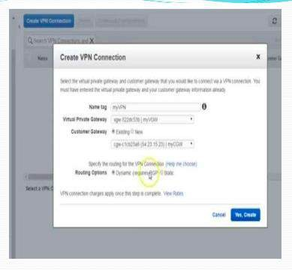

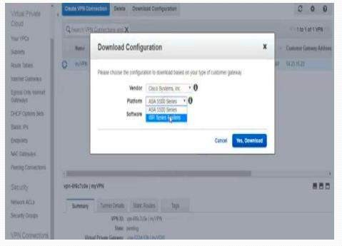

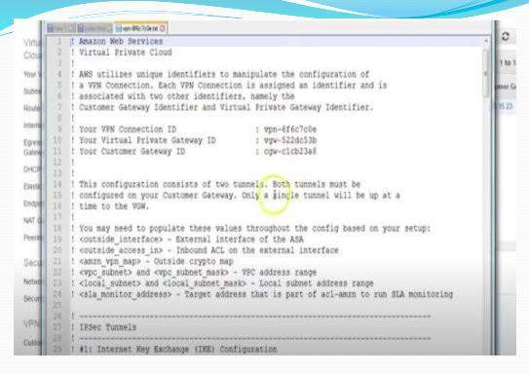

**Practical 19:**

**Implement & Configure load balancing with all necessary steps.**

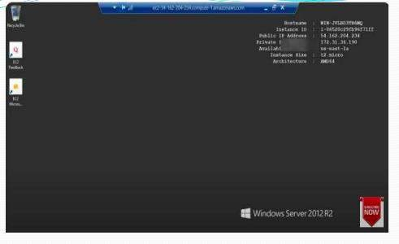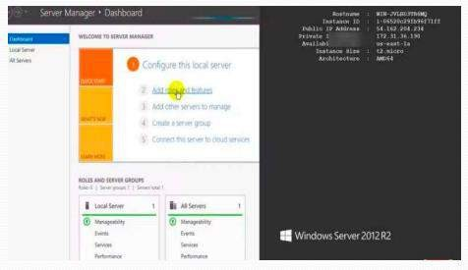

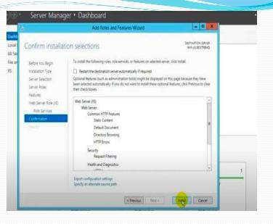

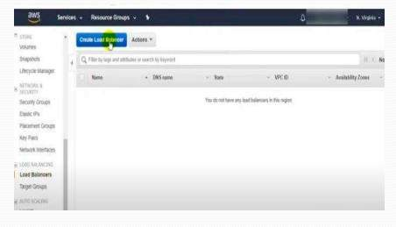

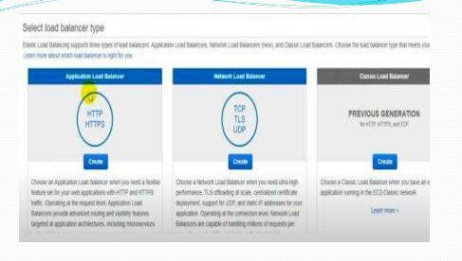

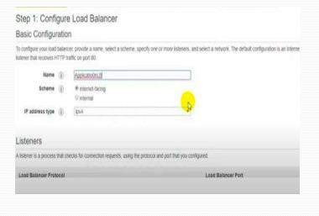

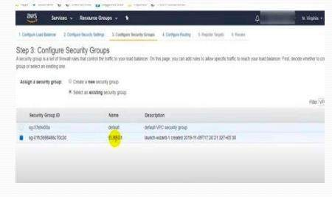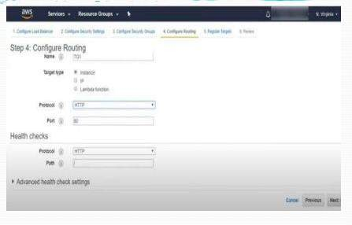

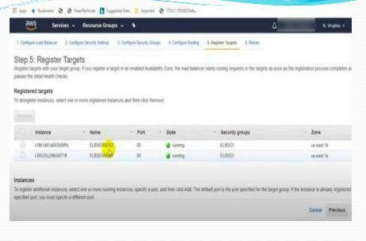

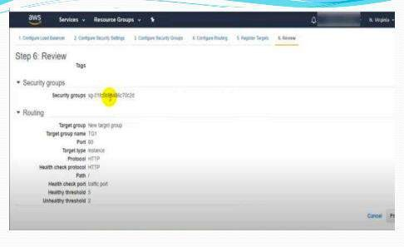

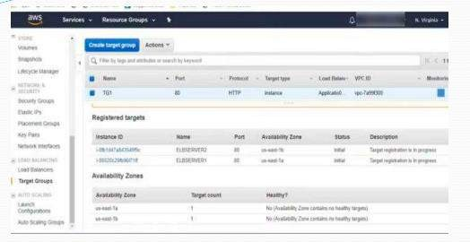

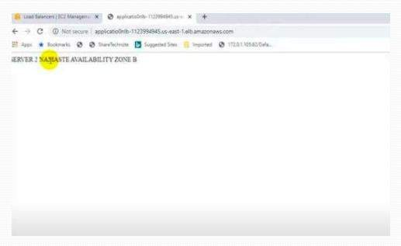

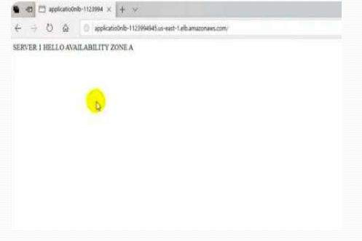

**Practial 20:**

**How to handle a cloud shell. Explain it**

### Steps to use AWS Cloud shell:

Using AWS CloudShell is a convenient way to access the AWS Command Line Interface (CLI) and various AWS services directly from your web browser,

Here are the steps to use AWS CloudShell:

### Login to the AWS Management Console:

Ensure you have an AWS account

and are logged into the AWS Management Console.

### Access AWS CloudShell:

Once you're logged in, you can access AWS CloudShell

from the AWS Management Console. You can find it in the top-right corner of the AWS Management Console, labeled as "AWS CloudShell."

### Initialize the Environment:

The first time you access CloudShell, it may take a moment to initialize your environment. Once it's ready, you'll be presented with a command-line interface.

### Use the AWS CLI and AWS SDKS:

CloudShell comes pre-configured with the AWS CLI and various AWS SDKs.

* 1. You can use these tools to interact with AWS services. For example, you can run AWS CLI commands, Python scripts, or
  2. use any of the supported SDKs to manage your AWS resources.

Customize Your Environment (optional): You can customize your CloudShell environment by installing additional packages

* 1. or configuring your shell as per your preferences. You can use package managers like pip, npm, or brew to install

**Save Your Work**: AWS CloudShell provides you with home directory

storage that is persistent, even across sessions. This means you can save your scripts, configuration files, and other data within your home directory.

**Exit CloudShell**: When you're done with your session, you can type exit to exit CloudShell. Your home directory data will persist for the next time you log in.

# Practical 21:

## Create a private cloud on google drive and grant permission for the user.

### Steps to Create a Private Cloud on Google Drive:

1. **Sign in to Google Drive:**

Open your web browser and go to Google Drive.

Sign in with your Google account or create one if you don't have it.

### Create a New Folder:

Click on the "+ New" button on the left side. Choose "Folder" to create a new folder.

Name the folder appropriately, e.g., "Private Cloud."

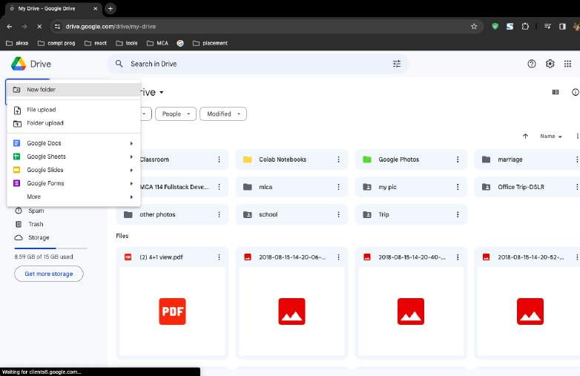

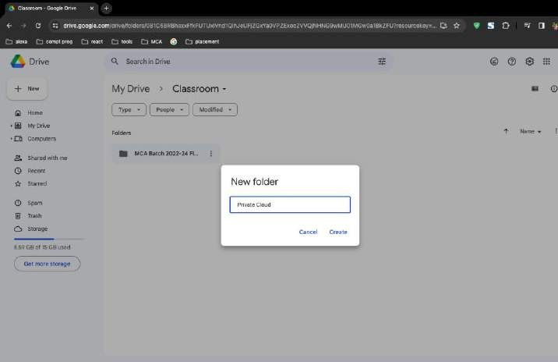

### Share the Folder:

Right-click on the folder you just created. Select "Share."

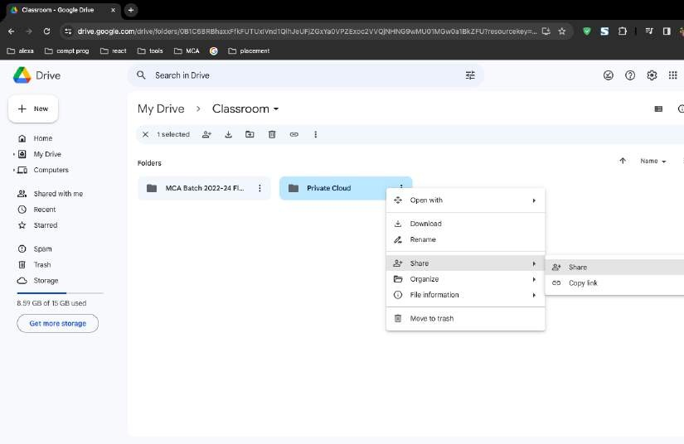

### Add Users:

In the sharing dialog, enter the email addresses of the users you want to grant access to.

Choose the appropriate access level (e.g., Viewer, Commenter, Editor) based on the level of access you want to provide.

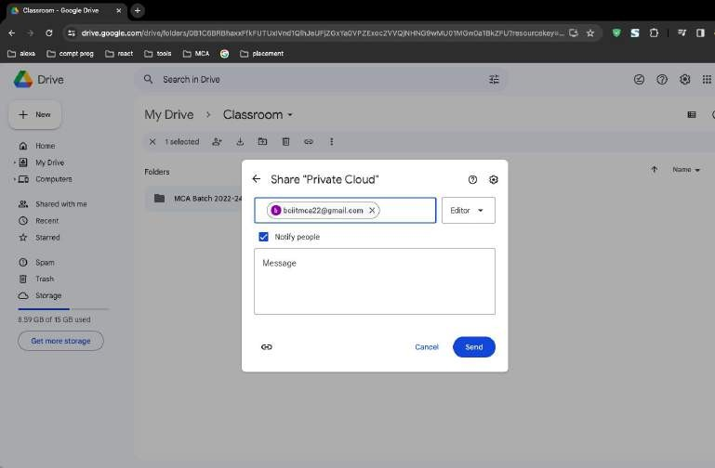

### Configure Advanced Settings (Optional):

Click on "Advanced" in the sharing dialog.

Adjust settings like link sharing, preventing editors from changing access, etc.

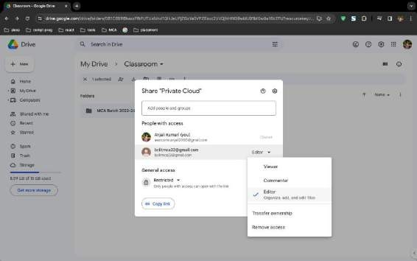

### Send Invitations:

Click on "Send" to send invitations to the specified email addresses.

Users will receive an email notification and can access the shared folder through their Google Drive.

### User Access Management:

As the owner, you can manage access at any time by right-clicking on the folder, selecting "Share," and modifying permissions.

